Working paper prepared for the IOTC MSE Task Force (March 2019, Ispra, Italy)

Indian Ocean Bigeye Tuna MSE
Operating Model Update March 2019
Dale Kolody (dale.kolody@csiro.au)
Paavo Jumppanen
(Eveson, Farley?)
CSIRO, Australia

To do: (Paavo's job jar)
Skip the MP evaluation results for OMgrid19.1 - the alternate growth curve throws a spanner in the results, that we can justify discarding for other reasons
3) Tune gridB19.4 for most sensible (central?) tuning level and default MP
-compare MP results among B19.2, 3, 4 for the base tuning above
-partition B19.4 result distributions by i) CPUE CV and ii) area-weighting factor
-discuss whether OM conclusions based on stock status results conclusions are qualitatively similar to those based on MP performance
4) Conduct all 3 TCMP requested tunings for gridB19.4
-add additional tuning if current space is not adequate
5) projection robustness tests
-to the WPTT list, add:

...low priority
-alternate low CPUE CV (e.g. 0.02) to show how much informaiton content affect behaviour
-alternate low rec CV (e.g. 0.1*current) to show how much recruitment variability affects MP behaviour

7) FAO Logo request and acknowledgements
For purposes of YFT grid:
SD(log(BET MSY gridB19.5)) = .331
SD(log(BET B/BMSY gridB19.5)) = 0.290
Corr = 0.79

Summary
The working paper describes developments on the IOTC bigeye operating model since the 2018 WPTT and WPM. Key points include:
- Most of the OM ensembles discussed in this report include one or more problems that are expected to be trivial for the purpose of MP evaluation and selection. These problems should all be easy to address before the 2019 TCMP, if an approach can be agreed by the MSE task force. The problems relate to:
  - An error in the interpretation of regional scaling factors for CPUE indices (a partial rerun suggests that this has a negligible effect, but there was not time to repeat all OM conditioning).
  - Minimization sensitivity to initial parameter values. The approach discussed below suggests that this should not cause a real problem for an OM ensemble (but remains a concern if management advice is based on a single or small number of models).
  - Parameters on bounds - there are instances in which the parameter bounds inherited from the assessment seem to preclude perfectly reasonable selectivity functions. Relaxing the bounds (and priors) can easily resolve the problem in some cases, but may allow implausible selectivity functions in other cases. The initial fishing mortality bound is also a problem in some cases.
- It was not possible to produce an alternative BET growth curve that sensibly merged the western Indian Ocean tag growth increment data with the eastern Indian Ocean otolith data using the existing statistical approaches (i.e. the data are too incompatible). An alternative ad hoc growth curve was produced by combining the two growth curves with a high weighing on the Western curve for younger ages and a high weighting on the Eastern curve for older ages. When combined with the higher CL sample size assumption and low M, the ad hoc growth curve was associated with implausible population dynamics (poor fit to early CPUE combined with dubiously high initial depletion). This suggests that growth uncertainty may well be important, but we omitted this scenario from the reference case at this time because it is not really a defensible scenario given the available data.
- Additional attention was given to the issue of numerical stability and model convergence in 2019. Instead of simply rejecting models that failed to meet the gradient-based convergence criterion, the minimization was automatically repeated from jittered initial parameter values, until convergence (maximum absolute gradient < 0.01) was achieved (or a maximum number of failures was reached). All configurations were able to meet this criteria.
- The automated minimization was also used to replicate (3 times) convergence to examine minimization sensitivity to the in initial conditions. The objective function values at the minimum varied by a mean of ~20 likelihood units (with a few values over 200). However, the stock status (MSY and B/BMSY) CV within a model was an order of magnitude smaller than the stock status variability among models (based on the best convergence). There was no evidence that a better likelihood was associated with a lower gradient among those models that reached the gradient threshold. Only the lowest objective function model was retained for the OMs.
- A fractional factorial design was used to evaluate an initial grid with 9 sets of interacting assumptions (each with 2 levels). The partially-confounded design used 128 models and was designed to allow estimation of all main effects and 2 way interactions. The corresponding full factorial would have required 512 models. The fractional design is balanced in that each level of a given assumption is represented an equal number of times. Three level options were reduced to the highest and lowest at this stage. The intent of this grid was to prioritize factors and reduce the dimensionality for the reference case OM.
- The stock status estimates appear to be sensitive to steepness, M, catchability trend, inclusion of the tagging data, CPUE standardization method and CL sample size assumptions. The stock status estimates appear to be least sensitive to the CPUE CV assumptions and the CPUE regional scaling factors.
- OMgridB19.4 is a 288 model ensemble proposed as the reference case OM for the 2019 TCMP (but subsequently found to contain an error in the application of the regional scaling factors). Comparing the full factorial grid (288 model) with fractional grids, we note that:
  - The fractional 144 model grid (with all main effects and two way interactions estimable) appears essentially identical in terms of both stock status estimates and MP evaluation outcomes.
  - The fractional 72 model grid (with only main effects estimable for the 2-level factors) resembles the full grid in terms of stock status estimates except the distribution is somewhat polymodal. The MP evaluation boxplots are virtually indistinguishable from the 288 model grid.
- A subset of MP evaluation results for OMgrid19.4 are presented for discussion in relation to the TCMP requirements.
- Do we need to add another tuning objective?
Summary points are presented for discussion and/or endorsement from the IOTC MSE task force.
The issue of evaluating plausibility of models within a large grid remains unresolved. We speculate that the current diagnostics and ad hoc inspection process should identify outlier behaviour in the gross system features that are likely to be relevant for MP evaluation, however, we expect that undesirable characteristics might be evident in some models if they were explored in detail.

Introduction

OM ensembles examined in this iteration
Table 1 lists the OM configurations and rationale. Grid factor details are provided in Table 2, with elaboration of new options provided in the text below (other options are explained in earlier documents).
Table 1. Operating Model definitions. The OMs are listed in the order discussed in the text, reflecting the sequence of development.
OM Ensemble | Rationale (factor abbreviations are defined in Table 2)
OMgridB19.0 | 72 models with 9 factors in a fractional factorial design. Intent was to screen features for relative importance. Factors  h70, h80, h90 (SR steepness)  M10, M08, M06 (M)  t0001, t10 (tag-weight)  q0, q1 (catchability trend)  iH, iC (LL CPUE standardization method)  iR1, iR2 (regional scaling factors applied correctly)  gr1, gr2 (growth curve)  ess10, CLRW (CL assumed sample sizes)  SL, SD (longline selectivity function)  (i2 - LL CPUE CV 0.2 only)
OMgridB19.1 | (not reported due to configuration error)
OMgridB19.2 | Contains an error in CPUE regional-scaling factor application, but is retained for discussion of convergence and fractional design. Subset of OMgridB19.4 - 72 models with 7 factors in a fractional factorial design that quantifies main effects (2 way interactions are confounded)  h70, h80, h90  M10, M08, M06  t0001, t10  q0, q1  iH, iC  i1, i3  ess10, CLRW  (gr1)
OMgridB19.3 | subset of OMgridB19.4 - Same 7 factors as OMgrid19.2, but with 144 model fractional factorial design that enables estimation of main effects and 2 way interactions. Contains an error in CPUE regional-scaling factor application, but is retained for discussion of convergence and fractional design
OMgridB19.4 | Same 7 factors as OMgrid19.2, but with 288 models in the full factorial design (all interactions are calculated). Contains an error in CPUE regional-scaling factor application, but is retained for discussion of convergence and fractional design
OMgridB19.5 | Proposed reference case OM - 144 models with 9 factors in a fractional factorial design with all 2-way interactions. Factors:  h70, h80, h90 (SR steepness)  M10, M08, M06 (M)  t0001, t10 (tag-weight)  q0, q1 (catchability trend)  iH, iC (LL CPUE standardization method)  iR1, iR2 (regional scaling factors)  ess10, CLRW (CL assumed sample sizes)  (i2 - longline CPUE CV = 0.2 only)  (gr1 - original growth curve only)
...these are cut and paste, need to check which were requested...
OMrobB19.4.recShock | A robustness scenario with 8 consecutive quarters of poor recruitment (55% of expected values, similar to estimates for YFT in the early 2000s). (conditioning is unchanged from OMrefB19.4)
OMrobB19.4.impErrCV10 | A robustness scenario in which each fishery has a 40% catch implementation error CV (independent by year and fishery). This corresponds to an annual aggregate CV >10%. (conditioning is unchanged from OMrefB19.4)
OMrobB19.4.under | A robustness scenario in which TACs are ignored for 10 years (fishing mortality constant at current levels) before the TAC is taken without error (conditioning is unchanged from OMrefB19.4)
OMrobB19.4.over | A robustness scenario with consistent 10% overcatch for all fleets (catch is accurately reported) (conditioning is unchanged from OMrefB19.4)
OMrobB19.4.qTrend3 | A robustness scenario with a longline CPUE catchability trend of 3% per year in projections (conditioning is unchanged from OMrefB19.4)
OMrobB19.4.ICV3 | A robustness scenario with a longline CPUE CV of 0.3 (aggregate annualized)
OMrobB19.4.ICVxxx | An exploratory scenario with a very small longline CPUE CV (aggregate annual = ) to explore what might be achievable with a good abundance index
OMrobB19.4.recCVxxx | An exploratory scenario with a very small recruitment CV (aggregate annual = ) to illustrate the effect of this assumption

Table 2. Model specification abbreviations. Bold indicates the BET assessment assumption(s). Some abbreviations may relate to additional explorations that were either not completed, reported in earlier iterations, or pertain to YFT.
Abbreviation | Definition
h70  h80  h90  Rh70  Rh80  Rh90 | Stock-recruit function (h = steepness)  Beverton-Holt, h = 0.7  Beverton-Holt, h = 0.8  Beverton-Holt, h = 0.9  Ricker, h = 0.7  Ricker, h = 0.8  Ricker, h = 0.9
iR1  iR2 | CPUE area-weighting factors  preferred estimate from Hoyle (2018)  alternate from Hoyle (2018) in which Region 2 represents the lowest proportion of the total vulnerable biomass
gr1  gr2 | mean Age-length relationship (growth curve)  original from assessment  speculative alternate curve produced for this report
sr4  sr6  sr8 | Recruitment deviation penalty  σ_{R} = 0.4  σ_{R} = 0.6  σ_{R} = 0.8
r55 | Future recruit failure  3 years of poor recruitment (2019-2022); mean dev = -0.55, consistent with 2015 YFT assessment
M10  M08  M06 | Natural mortality scaling factor relative to SA baseline level  1.0  0.8  0.6
t00  t0001  t001  t01  t10  t15 | Tag recapture data weighting (tag composition and negative binomial)  λ = 0  λ = 0.0001  λ = 0.01  λ = 0.1  λ = 1.0  λ = 1.5
q0  q1  q3  q5 | Assumed longline CPUE catchability trend (compounded)  0% per annum  1% per annum  3% per annum  5% per annum
iH  iC | Tropical CPUE standardization method  Hooks Between Floats  Cluster analysis
i1  i2  i3 | CPUE observation error  annual σ_{CPUE} = 0.2  annual σ_{CPUE} = 0.2  annual σ_{CPUE} = 0.3
x3  x4  x8 | Tag mixing period  3 quarters  4 quarters  8 quarters
SL  SD  S4  NS  ST  Sdev  Sspl | Longline selectivity (in conditioning)  Stationary, logistic, shared among areas  Stationary, double normal, shared among areas  LL selectivity independent among areas  Temporal variability estimated in 10 year blocks  Logistic selectivity trend estimated over time  15 years of recent selectivity deviations estimated  Cubic spline function (to admit possibility of dome-shape)
ESS2  ESS5  ESS10  CLRW  CL75 | Size composition input Effective Sample Sizes (ESS)  ESS = 2, all fisheries  ESS = 5, all fisheries  ESS = 10, all fisheries  ESS = One iteration of re-weighting; the output ESS from a reference case assessment specification (capped at 100)  ESS = One iteration of re-weighting; the output ESS from a reference case assessment specification raised to the power of 0.75 (capped at 100)

New assumptions in the March 2019 iteration

Alternate bigeye growth curve
The WPTT 2018 requested an additional growth curve in the BET OM uncertainty grid (partly in recognition of the change in stock status that arose in the WCPFC BET assessment (xxx) when that growth curve was updated). It was recognized that the growth curve of Farley (2006) offered an alternative with substantial contrast, because it included annual otolith counts from ages that are considerably greater than those examined from the RTTP tagging programme, and resulted in a considerably higher estimate of L∞.
Paige Eveson attempted to estimate a new growth curve that integrates the Farley (2016) otolith data (slightly revised using new methods) with the tagging data used for Eveson et al. (2012, 2015). However, the data sources are very inconsistent (e.g. Figure 1), and the results were implausible (e.g. Figure 2). The young length-at-age estimates from Eveson (2012) cannot be reconciled with the much larger fish of similar ages estimated by Farley (2016). The two stanza VBlogK growth curve attempts to explain the poor fit to the otolith data as a high degree of measurement error and/or assigns a substantial number of small fish to a negative age. Removing the younger otolith data (< 6 years) from Farley (2006) did not resolve the problem.
There are a number of mechanisms contributing to the bigeye growth uncertainty at this time:
- Farley (2006) otolith samples were obtained from longline catches in the Eastern Indian Ocean, and it would not be surprising if growth rates differ from the western region, where the tagging data come from.
- The bulk of the juvenile catches and tag recoveries come from the purse seine fisheries in the Western Atlantic. Size-based selectivity probably explains some of the observed length-at-age inconsistency, especially for juvenile fish. Note that only the two oldest fish (aged with daily otolith counts) from the western tagging study, appear to be consistent with Farley (2006). It would be interesting to know what fishery these came from.
- Temporal variability has also been noted in tuna growth, such that the different sample periods could also contribute to apparent inconsistencies.
- Methods for bigeye daily and annual ageing are currently in the process of being reviewed and refined. It is considered possible that the annual age estimates from Farley (2006) could be biased by between 1 and 2 years (which could greatly affect the early part of the growth curve, but not L∞).
At this time, there is not an alternative bigeye growth curve that is plausibly consistent with all of the data. In the interest of following up on the WPTT request, we simply merged the Eveson (2012) and Farley (2006) growth curves, with an ad hoc differential age-dependent weighting (i.e. Eveson 2012 for younger ages, transitioning to Farley 2006 for older ages), as shown in Figure 3.
As discussed below, the results suggest that the alternate growth curve has an appreciable effect on stock status estimates (comment on MP performance), however, we advise against using it in the reference case OM, because the ad hoc nature of the curve is not very defensible.

Figure 1. Comparison of Indian Ocean bigeye growth data from western and eastern locations (Paige Eveson, pers. comm.). Tag release ages were estimated by fitting a linear model through the west IO daily otolith data, then plugging release length into the model to estimate release age. The recapture age is the estimated release age plus the time at liberty.

Figure 2. Typical result of attempting to integrate the western and eastern bigeye age and growth data in a single model of the structure used in the past (Paige Eveson, pers. comm.). Eastern otoliths of age <6 years are omitted.
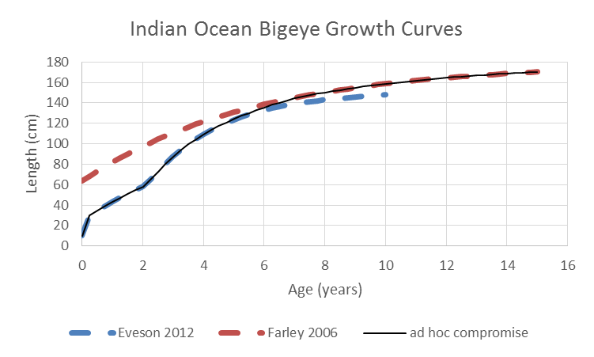

Figure 3. The alternative growth curve (ad hoc compromise) combining features of the existing western and eastern Indian Ocean growth curves.

CPUE series assumptions
Hoyle (2018) calculated dozens of new candidate CPUE regional scaling factors for bigeye (and yellowfin), all of which corrected an earlier problem (ignoring the change in 5x5 degree surface area due to changing latitude). The trends associated with the different CPUE targeting assumptions are shown in the OM was For the OMs, we included the new recommended value (analogous to the assessment and sensitivity runs identified for the yellowfin assessment), and the most extreme alternative in terms of having the highest ratio of biomass outside of area 2. Different CPUE assumptions are illustrated in Figure 4 - Figure 6. An error in the application of the regional scaling factors affects OmgridY19.2-19.4. This was corrected in the results shown for OMgridB19.0 and OMgridB19.5.

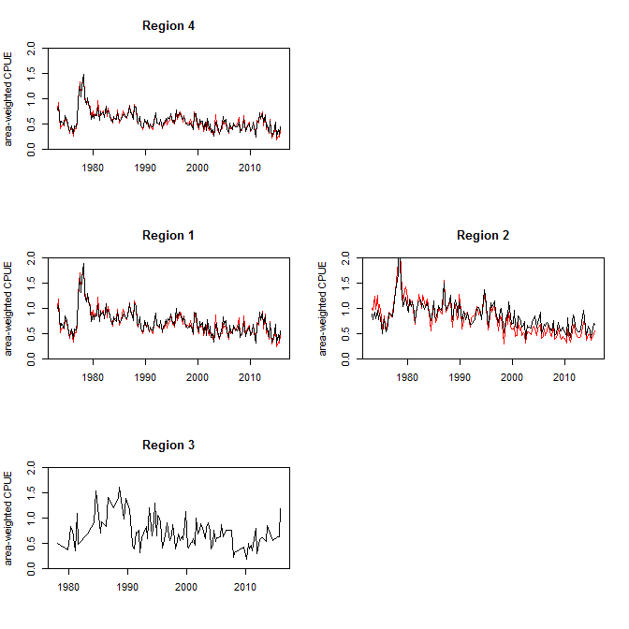
Figure 4. CPUE trends with clustering assumptions (black) and HBF (red) for the targeting assumption.

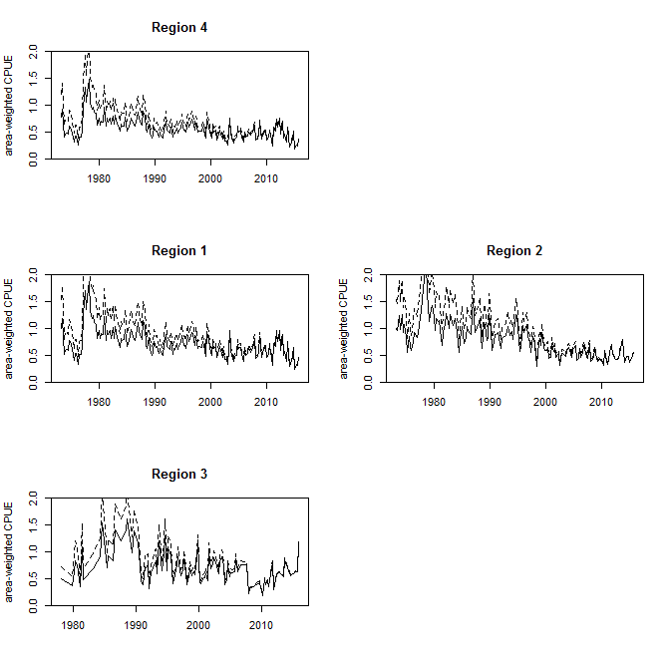
Figure 5. The default assessment CPUE series (solid line) and the 1% per year catchability trend series (broken line).

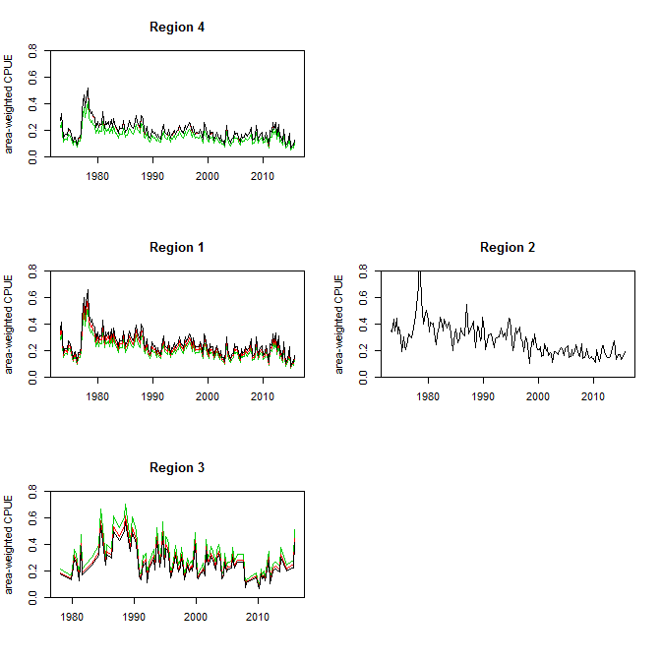

Figure 6. Comparison of the assessment CPUE series with the assessment area-scaling factors (black) and two alternates weighting factors (red, green).

Revised Projection Assumptions
The reference case OM projection assumptions were updated as recommended by the WPTT and WPM in 2018 (attachment 1), including:
- MP-based management was set to start in 2021, and the bridging catches for the intervening years were updated from the WPTT 2018 figures.
- The annual aggregate CV = 0.2 and auto-correlation = 0.5 was used (it was identified as a mistake in the previous iteration, but was actually correct). At this time, the OM only outputs the aggregate annual CPUE for the MP to use. Figure 7 illustrates an example stochastic time series with this level of error (and the level of variability that would be observed in 4 independent quarterly series that would result in the annual aggregate characteristics).

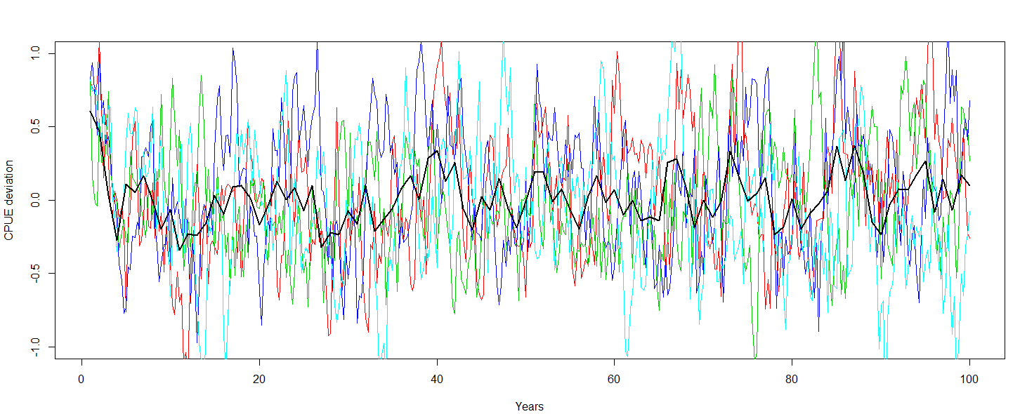
Figure 7. Simulated CPUE error time series yielding an annual aggregate (mean) CPUE series with a CV of 0.2 and auto-correlation of 0.5 (black line). Coloured lines represent 4 independent quarterly CPUE series errors that yield this aggregate characteristic.

Robustness trials

Fractional Factorial Experimental Design
The concept of fractional factorial design was developed in recognition that it is not practical to run experiments with every possible combination of interactions among a large number of factors, and even if it were possible, appreciable 3 way (and higher) interactions tend to be very rare. The principles of fractional factorial design have been used for OM development dating back to at least Schweder (1997). The approach appears to be most common and accessibly described for situations focused on interactions among 2 level factors (three level factors are generally included to identify whether non-linear responses are important). We used the R package "planor" to propose fractional designs for mixtures of 2 and 3 level factors.
Three grids were defined to explore the implications of fractional factorial design and propose the new reference case OM (the two fractional grids are a subset of the full grid and did not require re-running). Unfortunately, specification errors were identified too late to repeat the exercise. But we consider the results to be informative with respect to the requirements for OM design.
- OMgridB19.2 - 72 model fractional design with main effects estimable
- OMgridB19.3 - 144 model fractional design with main effects and all 2-way interactions estimable
- OMgridB19.4 - 288 model full factorial design

The cost of the fractional design is the confounding of the interaction terms. Furthermore, since the usual intent of fractional design is to quantify the effects of different factors and the low level interaction terms, it is not clear whether the approach will actually lead to a reasonably representative OM ensemble.
We suggest that the best use of the fractional design would be to maximize the number of dimensions tested, while keeping the number of models to a manageable total of between 50-150. We would suggest that all 2-way interactions should be a target to aim for, while the results below suggest that estimable main effects might be sufficient to map out the main uncertainties. We do not know if this is a reasonable generalization for OMs - it could be specific to the BET situation, or possibly an artefact of the random way in which the confounding was assigned.

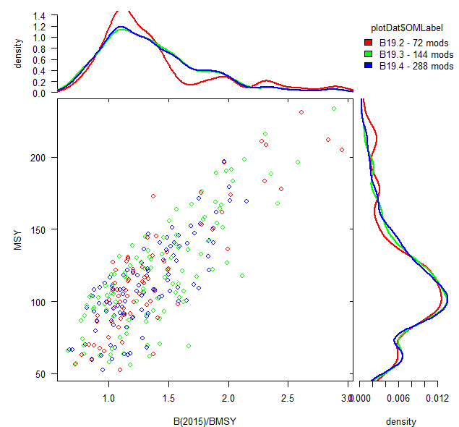
Figure 8. Scatterplot and marginal distributions for stock status summary statistics from grids B19.2, B19.3 and B19.4. Note that B19.3 includes points labelled B19.3 and B19.2, while gridB19.4 includes all points.

Parameter estimation sensitivity to initial values
It is recognized that parameter estimation is often sensitive to initial conditions in SS3 assessments (e.g. due to very flat and/or polymodal likelihood surfaces), and the bigeye model is no exception. It would be very difficult to ever conclude that one of these highly parameterized models has truly reached the global minima, so we have usually assumed that a model reaching the satisfactory convergence criterion (absolute value of the maximum gradient of the objective function with respect to the parameters < 0.01) should provide informative results, even if it is not perfect. This may be a particularly dangerous assumption if one is relying on a single (or small number) of models, but it is hoped that the problem should not be serious if the MSE is designed to be robust to many models. There is an additional concern that a large number of model failures in a particular parameter space could substantially distort the overall distribution of the OM ensemble. To examine these assumptions in more detail, the minimization was repeated from jittered initial parameter values, until 3 separate runs converged for each model configuration. A limit of ~10 fitting failures was imposed (but overridden in some cases). From this exercise we note:
- The summary results presented below are based on a flawed grid specification, but were qualitatively consistent among multiple grids (not shown). There was considerable variability in the number of attempts required to achieve convergence. Around 1000 model fittings were undertaken to achieve 3 convergences for a 144 model grid.
- There is non-trivial variability in the stock status results due to minimization variability, but this variability is much less than the variability observed among model configurations:
  - The objective function deviation from the minimum (within a model configuration) had a mean of 24 likelihood units (maximum 1681). Note that model A is ~20X more likely than model B if the (negative log) likelihood of model A is ~3 units lower than model B.
  - The mean (across all models) of the CV of the MSY variability (within model configurations) is small (3.8%) relative to the CV among all model configurations (with the best objective function value) 31%.
  - Similarly, the mean (across all models) of the CV of the B/BMSY variability (within model configurations) is small (~3.0%) relative to the CV among all models (with the best objective function value) ~19%
- The OMs are based on the converged models with the lowest objective function value. In so far as MSY and the depletion ratio can be interpreted as indicators of the effect of the numerical convergence problems, it is not obvious that the distribution of these "best" models differs appreciably from the results that would have been achieved from a random sample of converged models (Figure 9). Among all the converged models, there is no obvious indication that lower (maximum absolute value of the) gradients are associated with better objective function values (Figure 10). Thus there does not appear to be any reason to adopt a more restrictive gradient threshold for retention (perhaps it could be relaxed).
- The models with persistent convergence problems were often (possibly always) associated with very high exploitation rates (for at least one age-region combination), resulting in a runtime catch penalty that SS uses to steer the function minimizer away from impossible results (e.g. catch(age) > N(age)) without crashing. We speculate that this penalty introduces a steep gradient, that can conflict with other steep gradients from the likelihood terms. Thus the model may struggle to find a low gradient at the valley of these opposing terms, and if it does succeed in finding the true minimum, it may not be plausible. Furthermore, the implausible solution may often manage to barely avoid the catch penalty, and hence may be difficult to recognize in the SS output diagnostics.
- On the basis of these results, and given the time constraints, we opted to obtain successful convergence twice per model specification in subsequent grids.

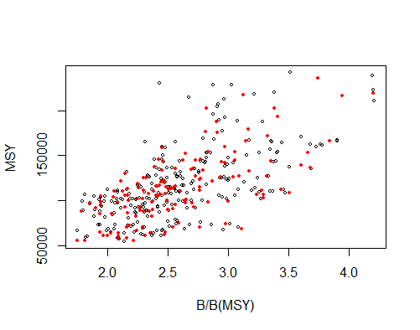

Figure 9. Comparison of stock status characteristics from all (432) of the converged models from the bigeye OM ensemble OMgridB19.1. Red points indicate the (144) best objective function value for each configuration.
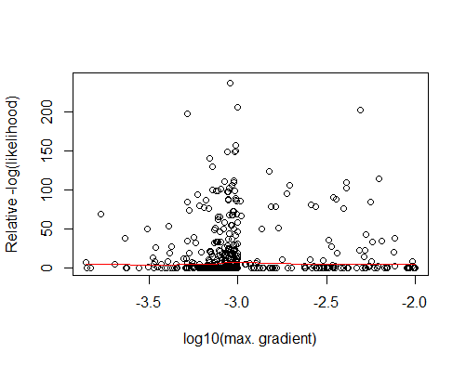

Figure 10. OMgridB19.1 comparison of the relative objective function values (i.e. L - minimum(L) within the 3 converged models for each of the 144 configurations) and the maximum gradient (for models meeting the minimum gradient convergence criteria). One point is off-scale (1681).

Parameters on Bounds
As in previous iterations of OM development, the configuration files for the bigeye OMs had several bounds and prior distributions relaxed relative to the original assessment, to reduce unintended consequences of these somewhat arbitrary constraints. This relaxation presumably has consequences for the minimization speed and sensitivity to initial conditions in some cases. In OMgridB19.1, there were a total of 170 lower parameter bound warnings, related to selectivity, movement and initial fishery depletion. These are probably not important, because 0 is a plausible solution, and a parameter will tend to approach 0 (or a negative bound in log-space) if this is the preferred solution (e.g. the difference in movement rate between 0.001 and 0.0001 should not have a material impact on model dynamics). There were 4 upper parameter bound warnings in OMgridB19.1, related to movement. We are also not concerned about these bounds. A movement rate of 100% seems unlikely, but it does not represent a logical problem and it would be hard to justify a particular alternative value given the current evidence. Similarly a high value that is <100% will result in mixing that is very rapid relative to a realistic exploitation rate.
However, we recognize that simply expanding bounds and priors is not always a satisfactory solution. Figure 11 shows the selectivity and poor fit to the size composition data for the pole and line fishery when the parameters managed to still hit the expanded bound (for the best fit model of 3 converged attempts). The other 2 converged models with the same specification yielded more reasonable results for this fishery, but a worse fit to the overall objective function. This is probably largely an artefact of the imperfect minimization process, given that this is a very small fishery, with very small sample CL sizes and not linked to any abundance indices. In this case, we opted for a mildly informative prior, but retained the relaxed bounds.
The most problematic bound relates to the initial fishery depletion. Several models from OMgridB19.1 estimate that the population is substantially depleted at the beginning of the model time period. This results in a poor fit to the early CPUE data (e.g. Figure 12), and is not very believable. This was only observed as an interaction among the low M, relatively high weighting on the size composition data, and the alternate growth curve. For the reasons discussed above, we opted to drop the alternate growth curve from the reference case OM at this time.

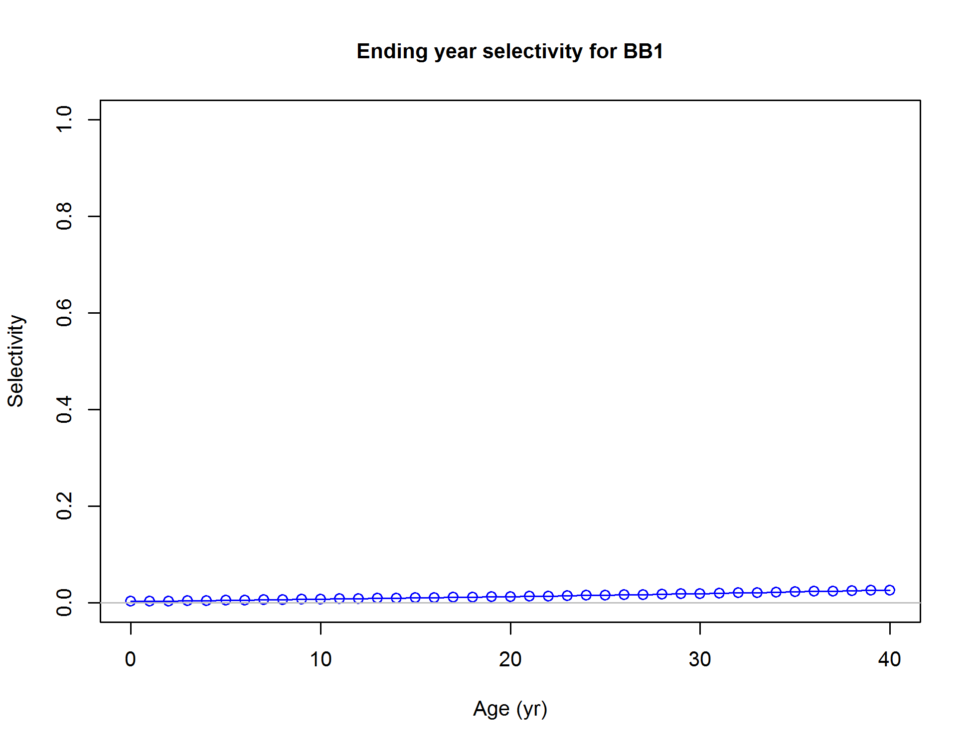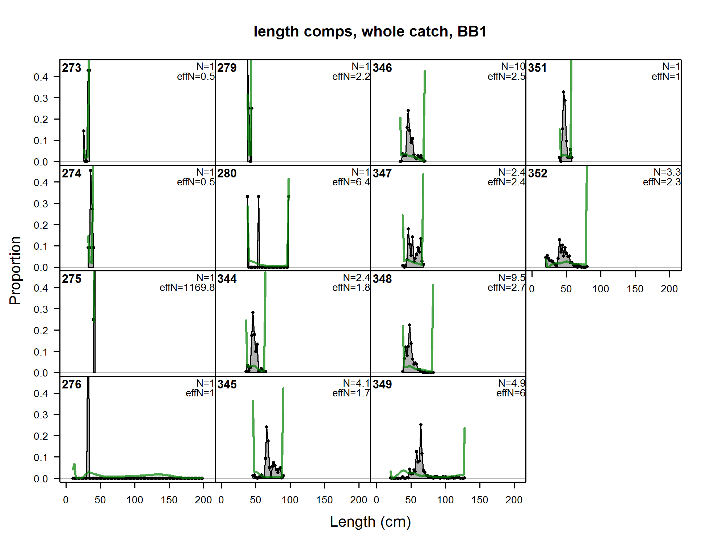

Figure 11. Example of implausible pole and line fishery selectivity hitting an extreme bound, and the corresponding poor fit to the (very limited) size composition data.
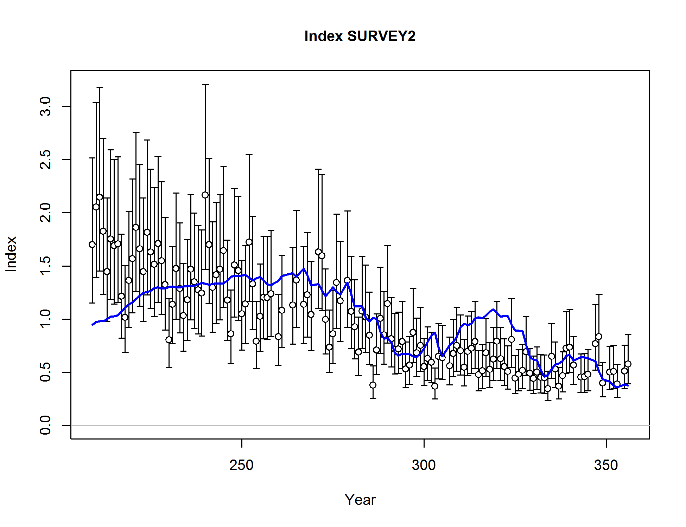
Figure 12. Example fit to the CPUE data from a model that hit the initial fishery depletion bound.

Comparison of Bigeye OM ensemble conditioning results
OMgridB19.0 - 72 model ensemble, fractional factorial main effects only
- The intent was to quantify main factor effects, and drop some factors if appropriate
- Figure 16 - Figure 20 compare a number of OM grid summary diagnostics, partitioned by model assumption for each of the 3 grids above. OMgridB19.1 summary diagnostics are shown in a multidimensional scatterplot in Figure 13, partitioned by growth and area-weighting assumptions. These figures suggest that there is considerable overlap among the results of the two growth curves, and among the area-weighting factors in OMgridB19.1. We interpret this to mean that these dimensions can be reduced to a single level (especially considering that the options proposed for removal have external plausibility concerns discussed previously).
- R package "planor" describes the aliasing in OMgridB19.1:

OMgridB19.2 - 72 model ensemble, based on OMgridB19.1 without the alternate growth curve and original CPUE area-weighting factors (2 X 3 level and 5 X 2 level factors), specified to identify the main effects, while 2 way (and higher) interactions are aliased. Note that simply dropping these dimensions from OMgridB19.1 results in a 36 model grid, but planor could not identify an equivalent 36 model design that allows all main effects to be estimated.

OMgridB19.3 - 144 model ensemble, OMgridB19.2 expanded fractional design to reduce aliasing of interactions (2 X 3 level and 5 X 2 level factors)
- Intent is to see whether missing interactions from OMgrid19.2 are likely to be influential in MP performance and selection.
- R package "planor" describes the aliasing in the design (the full factorial grid is 288 models as in OMgridB19.4):

********** Prime 2 design **********
UNALIASED TREATMENT EFFECTS
t.val ; q.val ; i.val ; iCV.val ; ess.val ; t.val:q.val ; t.val:i.val ; t.val:iCV.val ; t.val:ess.val ; q.val:i.val ; q.val:iCV.val ; q.val:ess.val ; i.val:iCV.val ; i.val:ess.val ; iCV.val:ess.val
ALIASED TREATMENT EFFECTS
nil
********** Prime 3 design **********
UNALIASED TREATMENT EFFECTS
h.val ; M.val ; h.val:M.val ; h.val:M.val^2
ALIASED TREATMENT EFFECTS
nil

OMgridB19.4 - 288 model ensemble, full factorial design.

The properties of the original 9 factor grid and the different 7 factor grids are compared in Figure 16 - Figure 20. The properties are broadly similar, however we might reach different conclusions about some factors. Notably the full factorial grid (B19.4), suggests that the marginal effect of the CPUE weighting factor (i1 vs i3) is probably not important, while the fractional grids (B19.2 and 19.3) suggest that there likely is an appreciable effect.
Figure 8 shows that the marginal distributions of MSY and depletion are extremely similar between B19.4 (full 288 model grid) and B19.3 (144 model grid). The smallest grid (B19.2 with 72 models) appears to describe the mode and tails of the distributions reasonable well, but there are multiple modes evident.
OMgridB19.5 - proposed reference case OM, 144 model ensemble, fractional factorial design with all main effects and 2-way interactions estimable.

********** Prime 2 design **********
--- Solution 1 for prime 2 ---
UNALIASED TREATMENT EFFECTS
t.val ; q.val ; i.val ; iRWt.val ; ess.val ; t.val:q.val ; t.val:i.val ; t.val:iRWt.val ; t.val:ess.val ; q.val:i.val ; q.val:iRWt.val ; q.val:ess.val ; i.val:iRWt.val ; i.val:ess.val ; iRWt.val:ess.val
ALIASED TREATMENT EFFECTS
nil
TREATMENT AND BLOCK EFFECTS CONFOUNDED WITH BLOCK EFFECTS
nil
UNALIASED BLOCK EFFECTS
nil
--- Synthesis on the aliased treatment effects for prime 2 ---
unaliased trt.aliased blc.aliased
[1,] 15 0 0
********** Prime 3 design **********
--- Solution 1 for prime 3 ---
UNALIASED TREATMENT EFFECTS
h.val ; M.val ; h.val:M.val ; h.val:M.val^2
ALIASED TREATMENT EFFECTS
nil
TREATMENT AND BLOCK EFFECTS CONFOUNDED WITH BLOCK EFFECTS
nil
UNALIASED BLOCK EFFECTS
nil

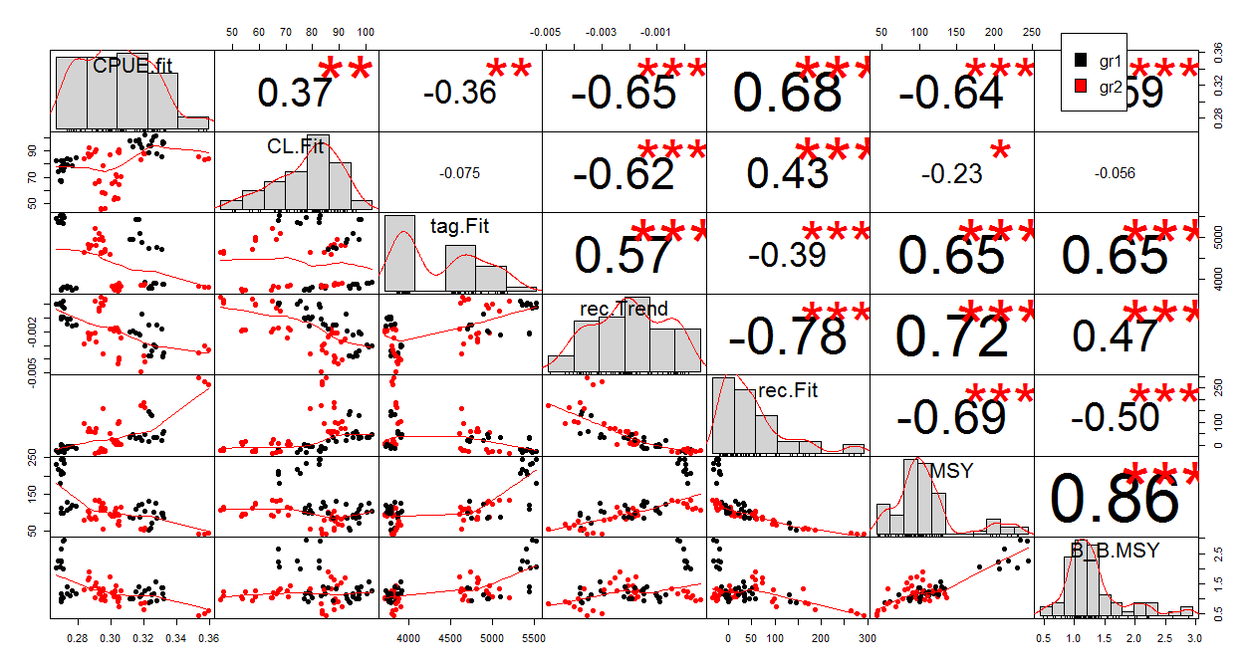
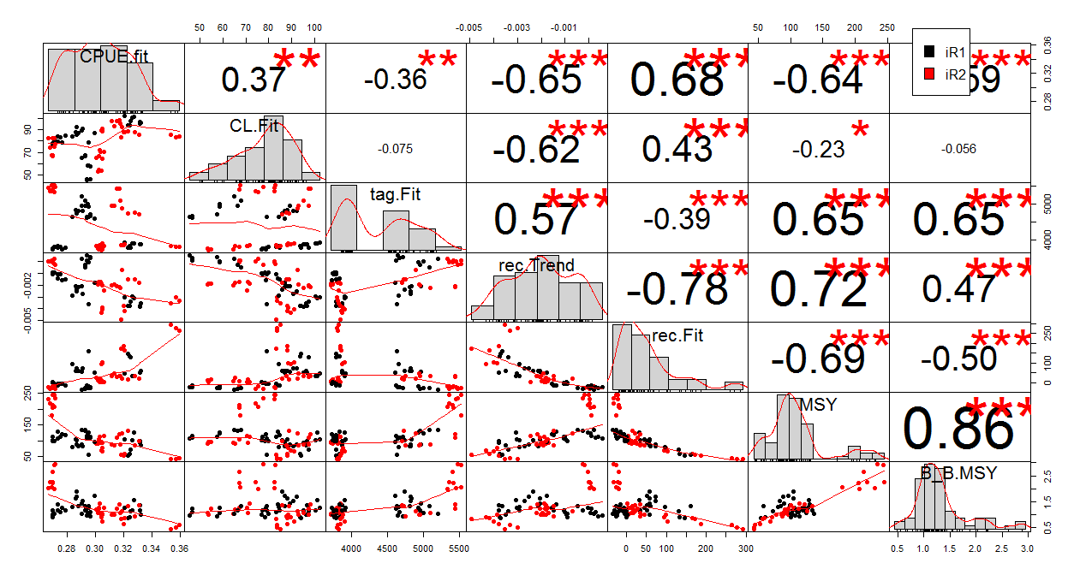
Figure 13. Multiway comparison of OMgridB19.0 model characteristics, partitioned by the dimensions that are proposed for simplification - growth (top) and CPUE area-weightings (bottom).

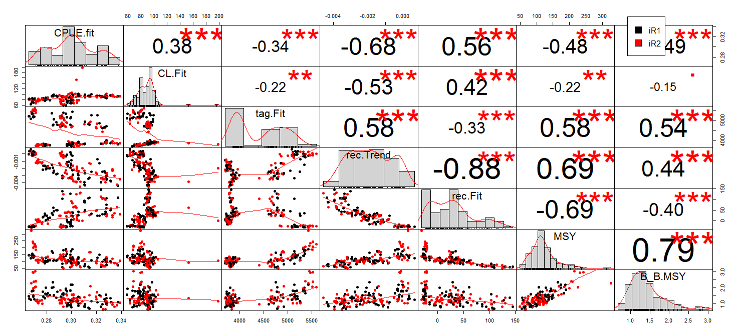
Figure 14. Multiway comparison of OMgridB19.5 model characteristics, partitioned CPUE area-weightings.

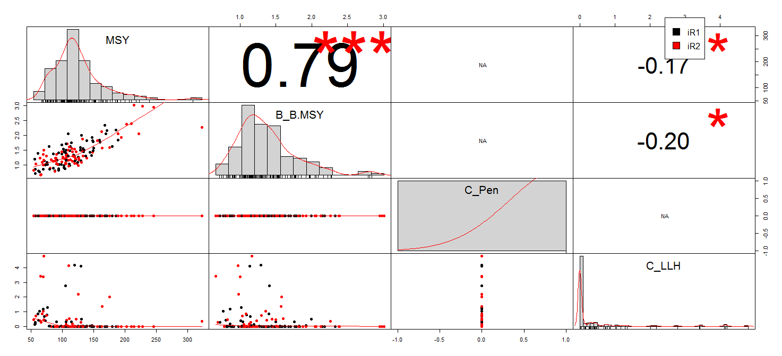
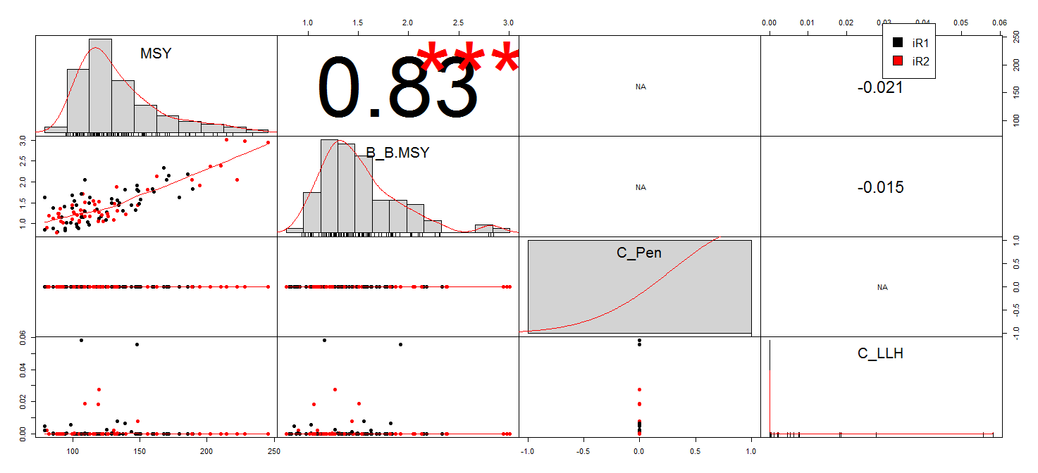
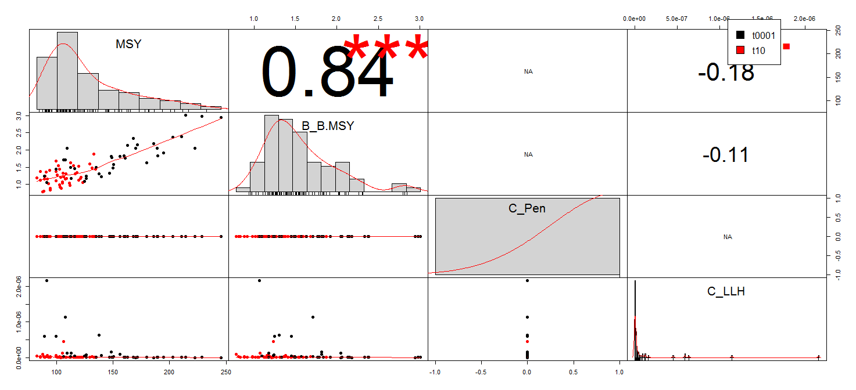
Figure 15. Multiway comparison of OMgridB19.5 model characteristics, comparing stock status and indices of numerical problems with catch calculations. Top panel is the full 144 model grid, middle panel is the subset of 104 models in which the catch penalty < 0.1, bottom panel is 84 models with catch penalty < 0.00001.

B19.0 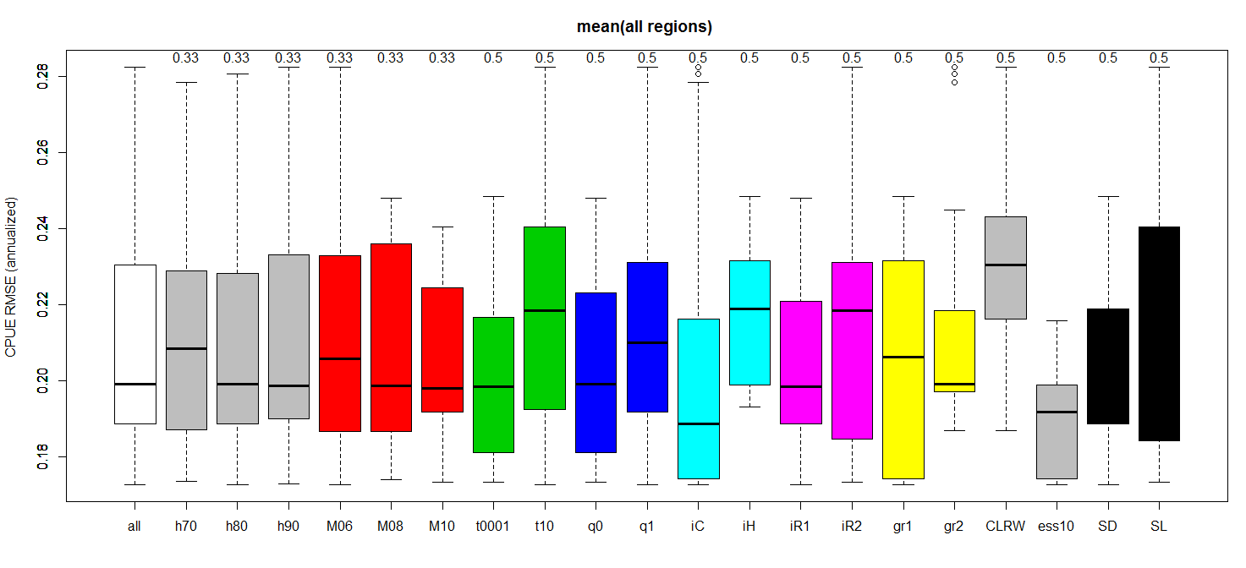
B19.5 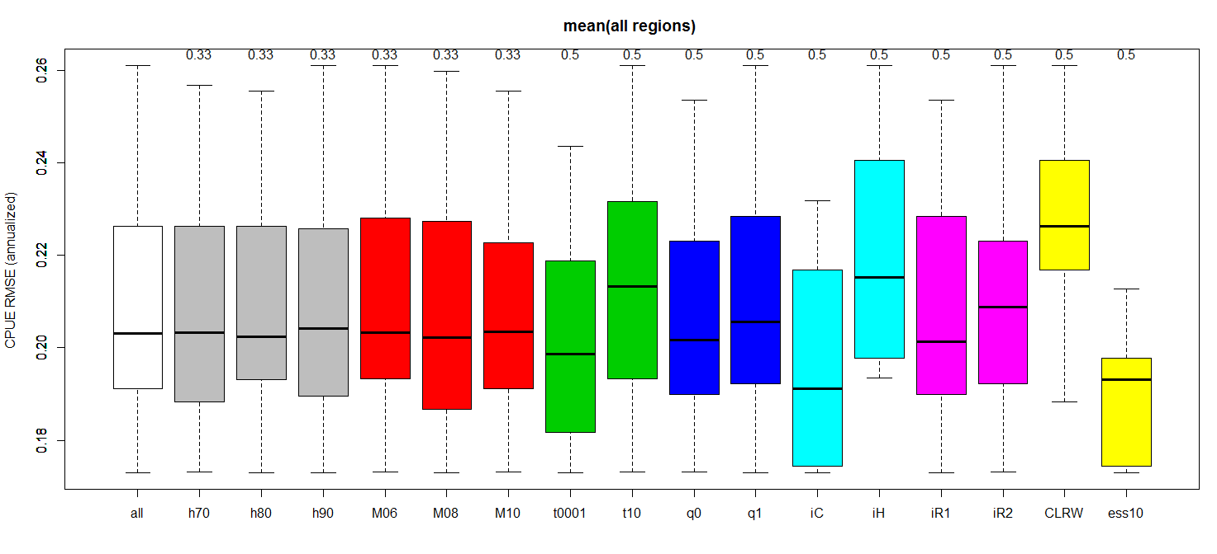
B19.2 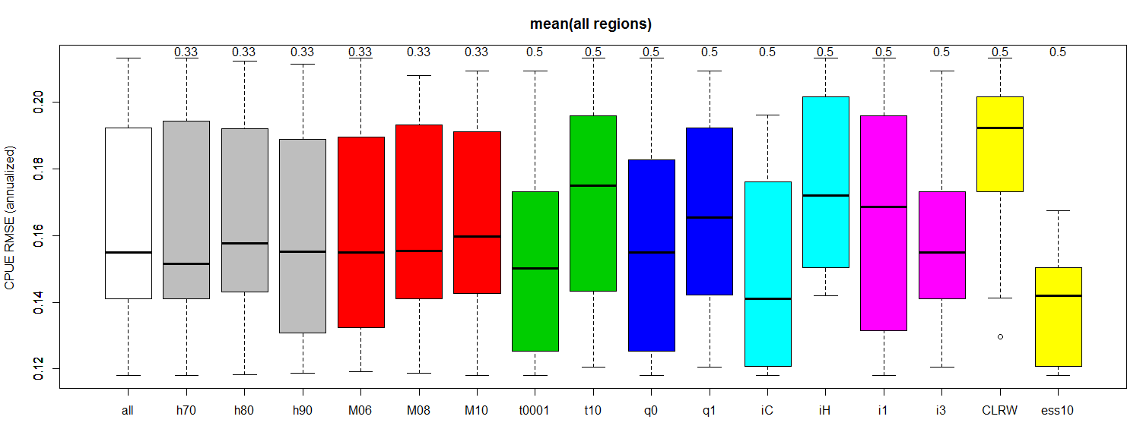
B19.3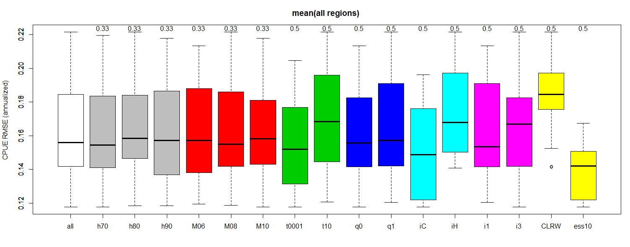
B19.4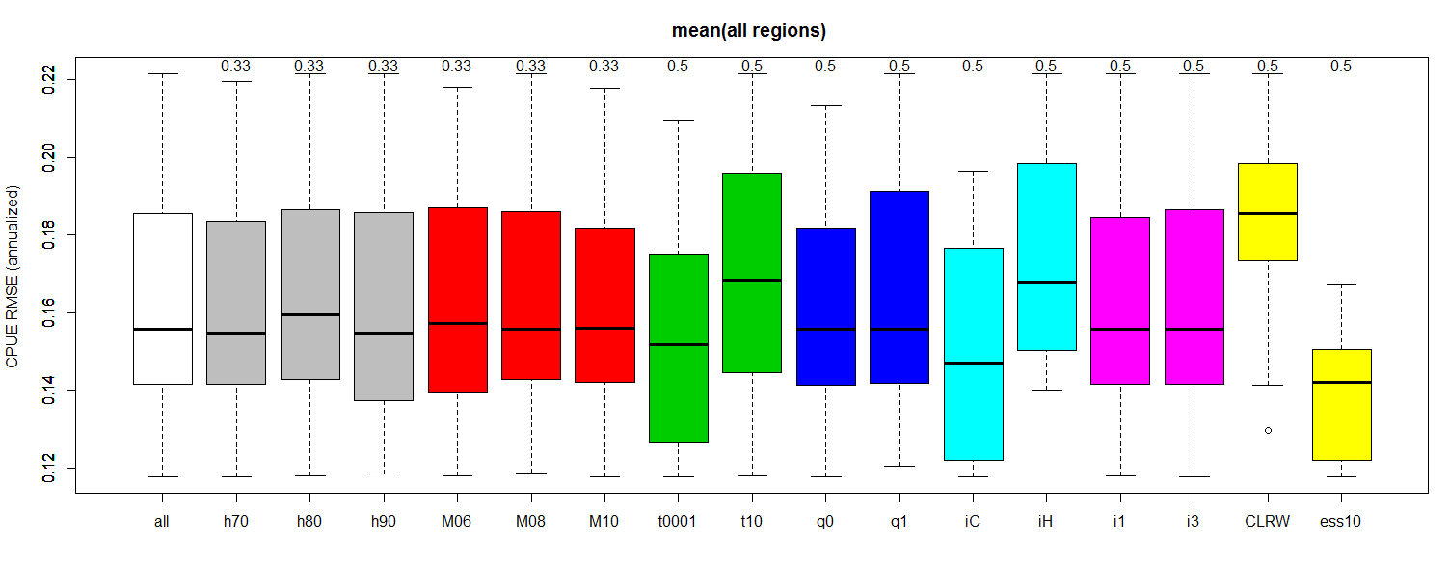
Figure 16. Comparison of CPUE fit among BET OM ensembles.

B19.0 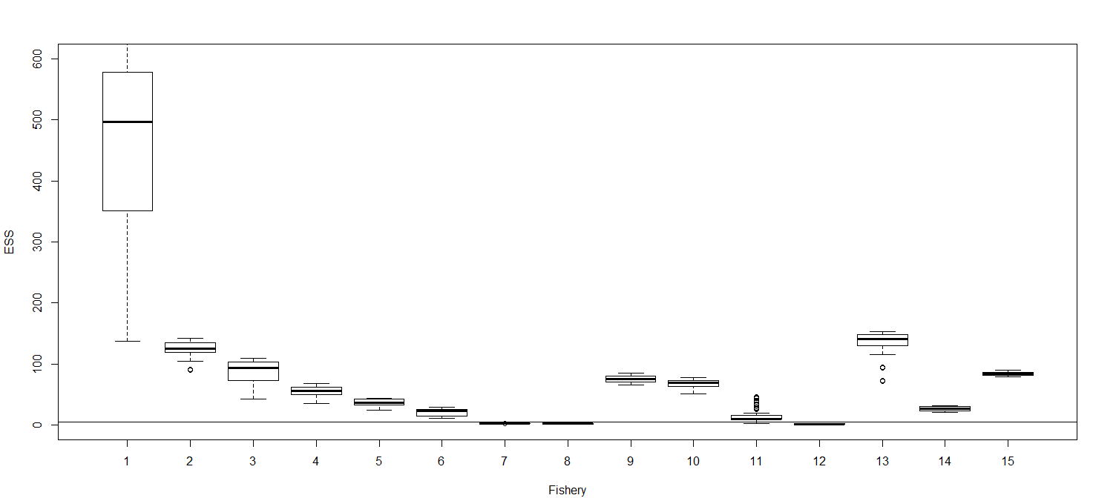
B19.5 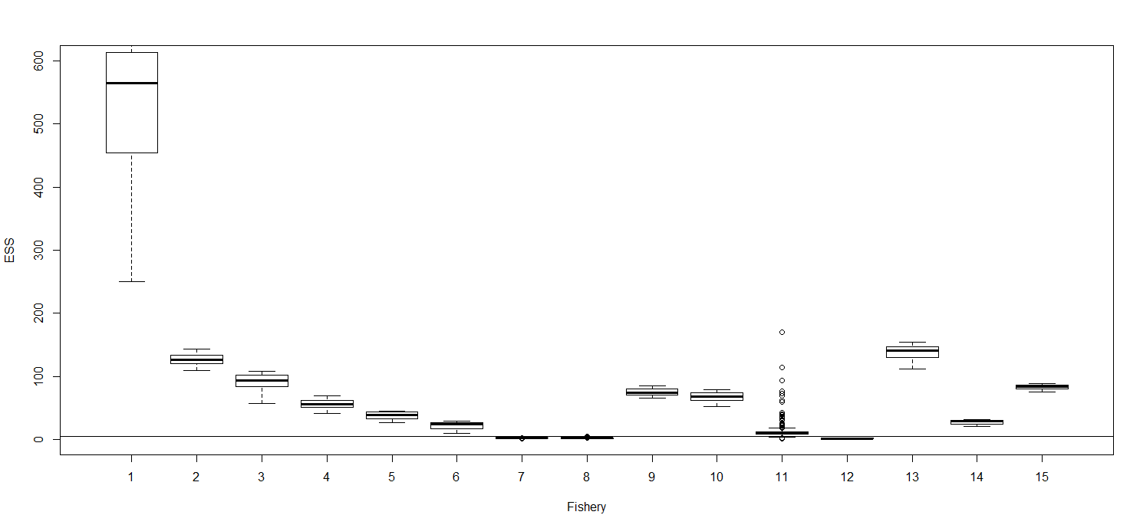
B19.2 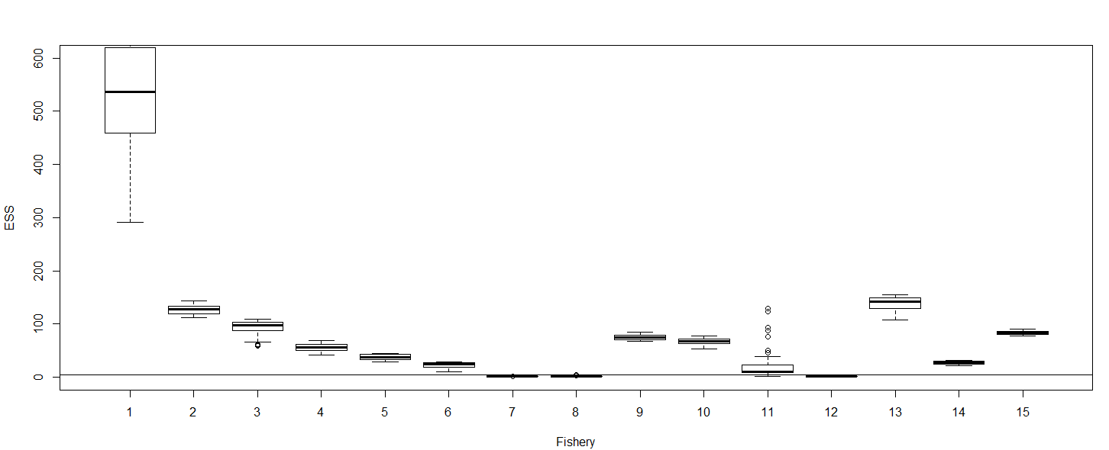
B19.3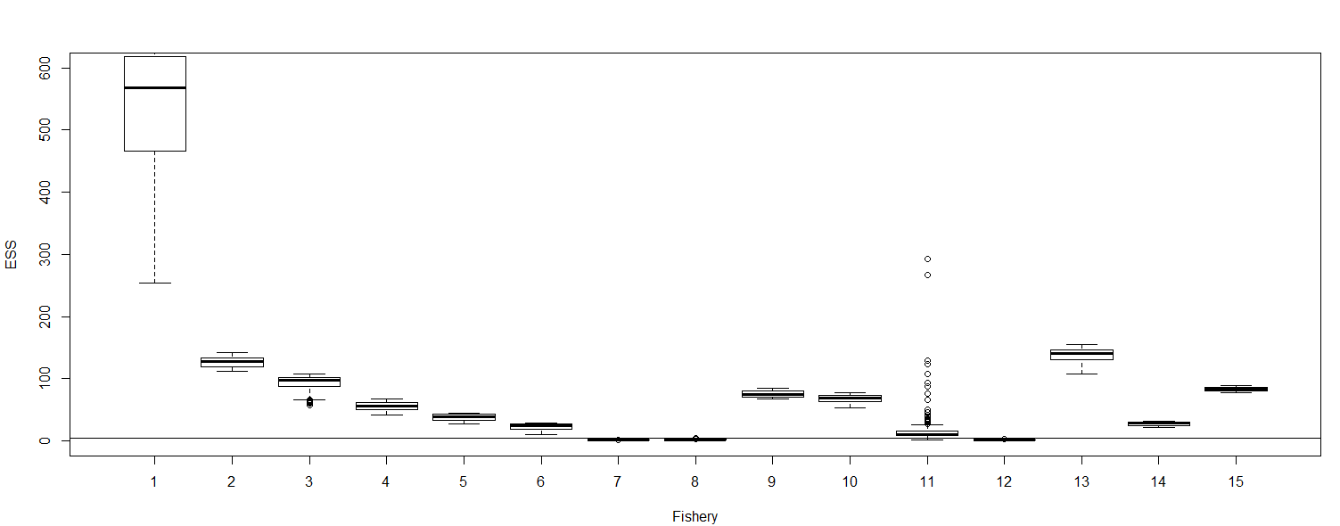
B19.4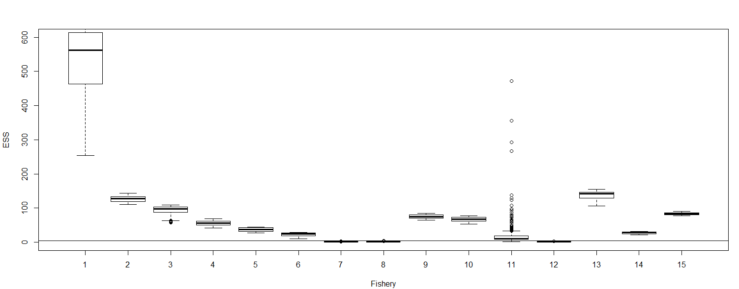
Figure 17. Comparison of CL fit among BET OM ensembles.

B19.0 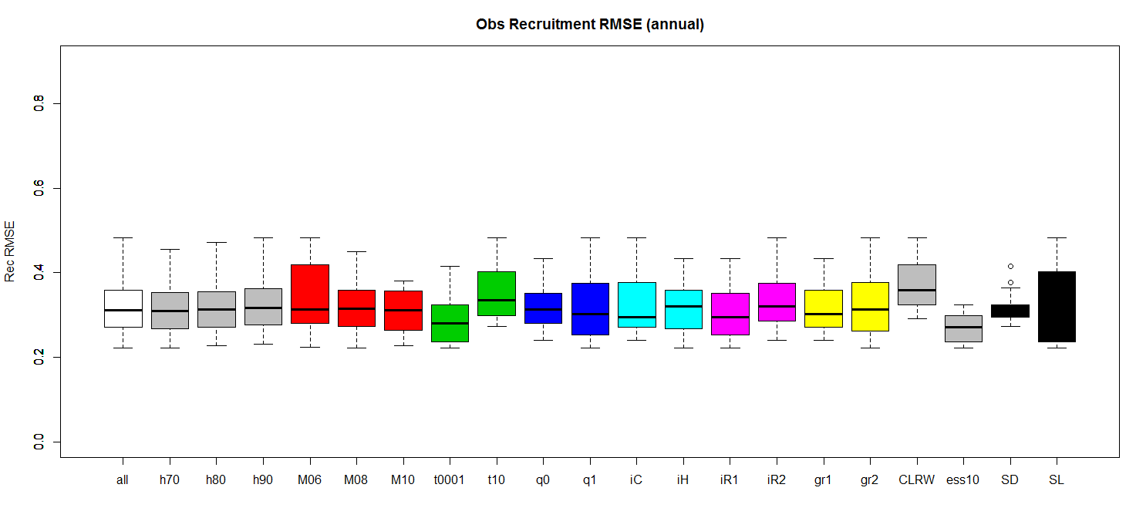
B19.5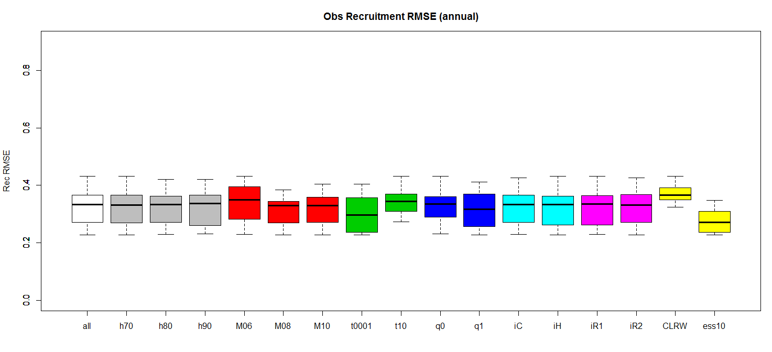
B19.2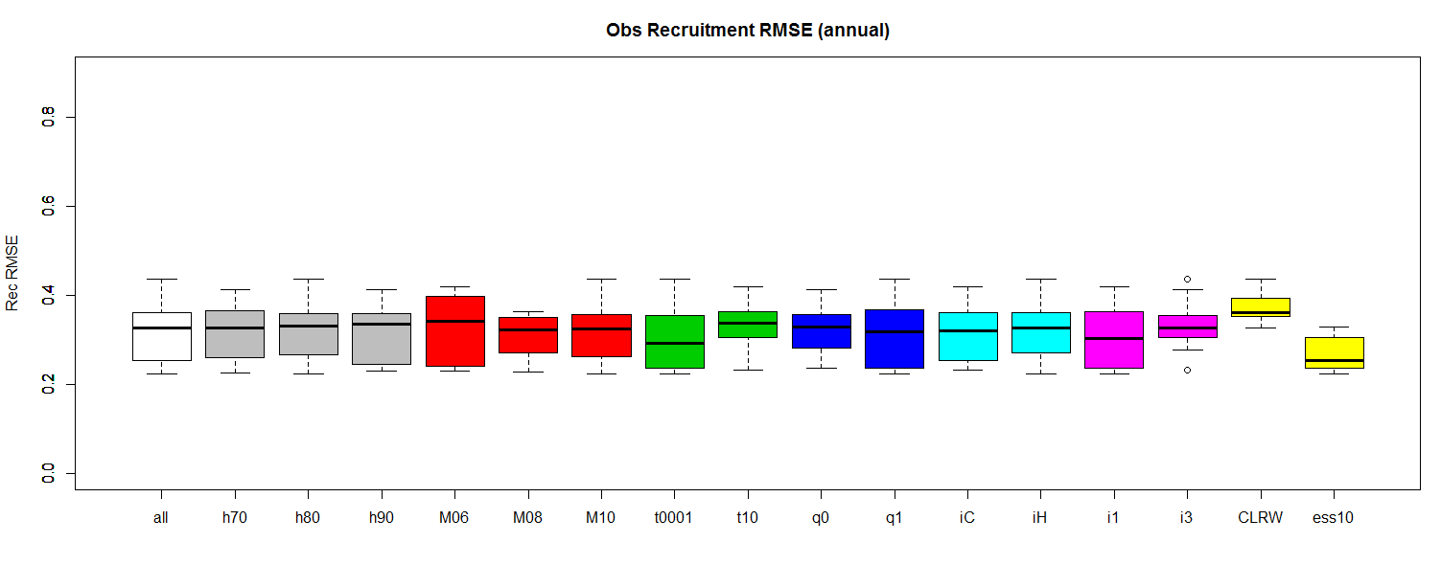
B19.3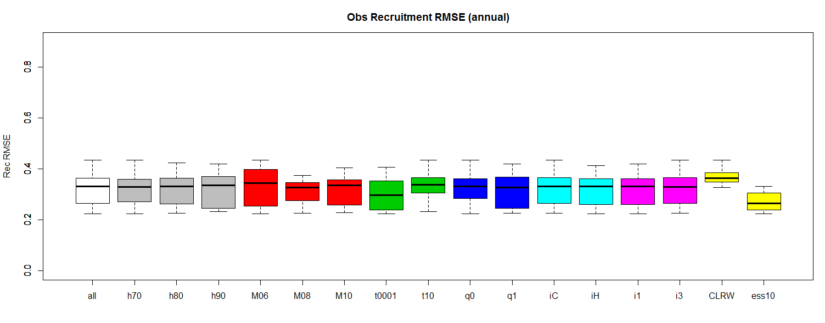
B19.4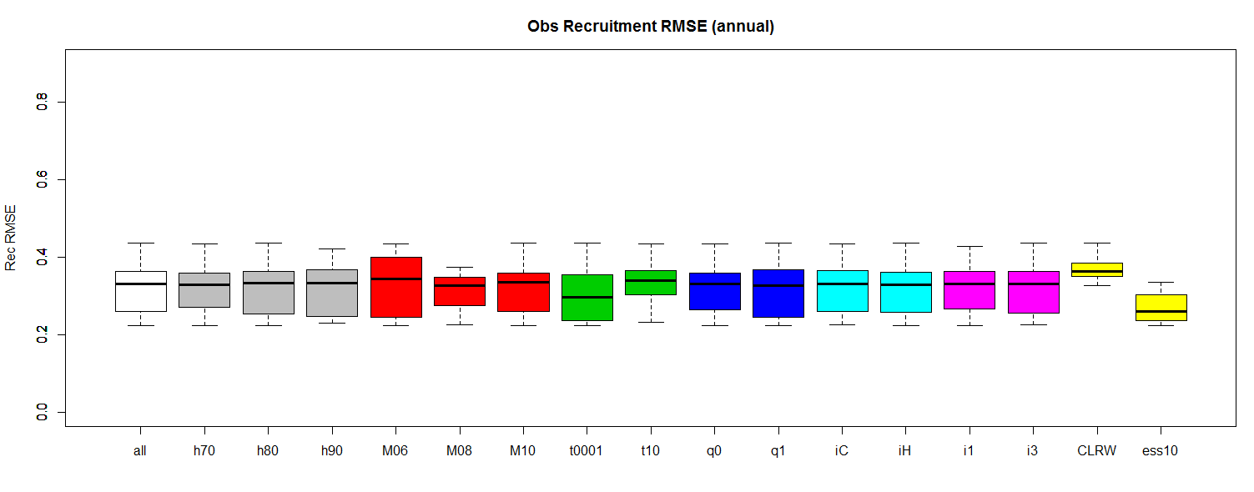
Figure 18. Comparison of Recruitment Deviation magnitude among BET OM ensembles.

B19.0 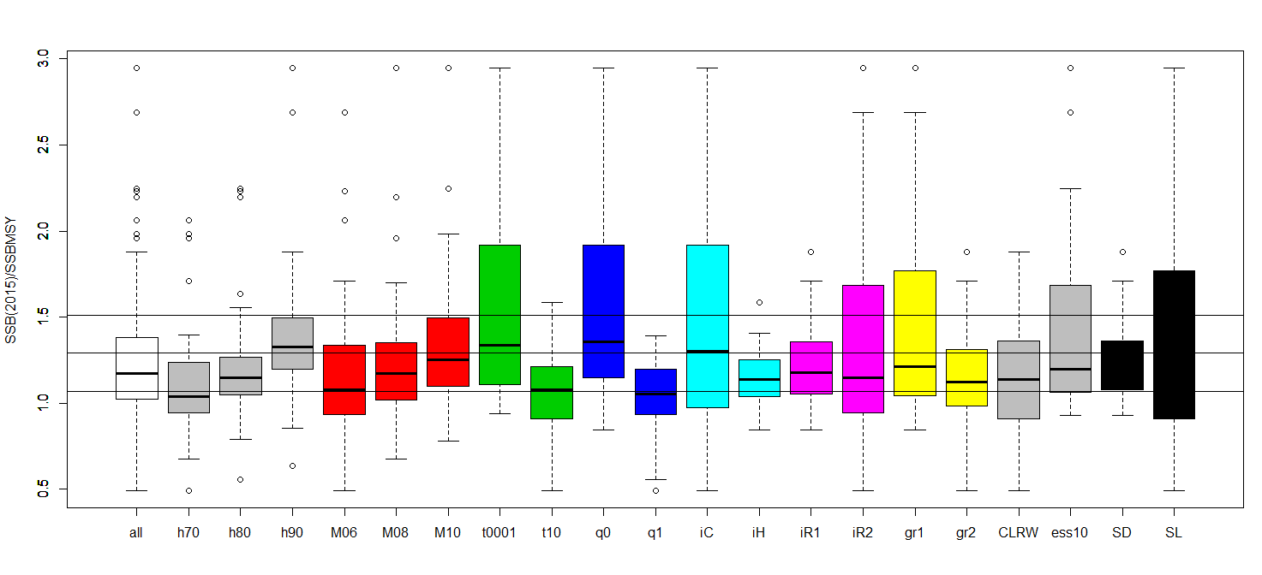
B19.5 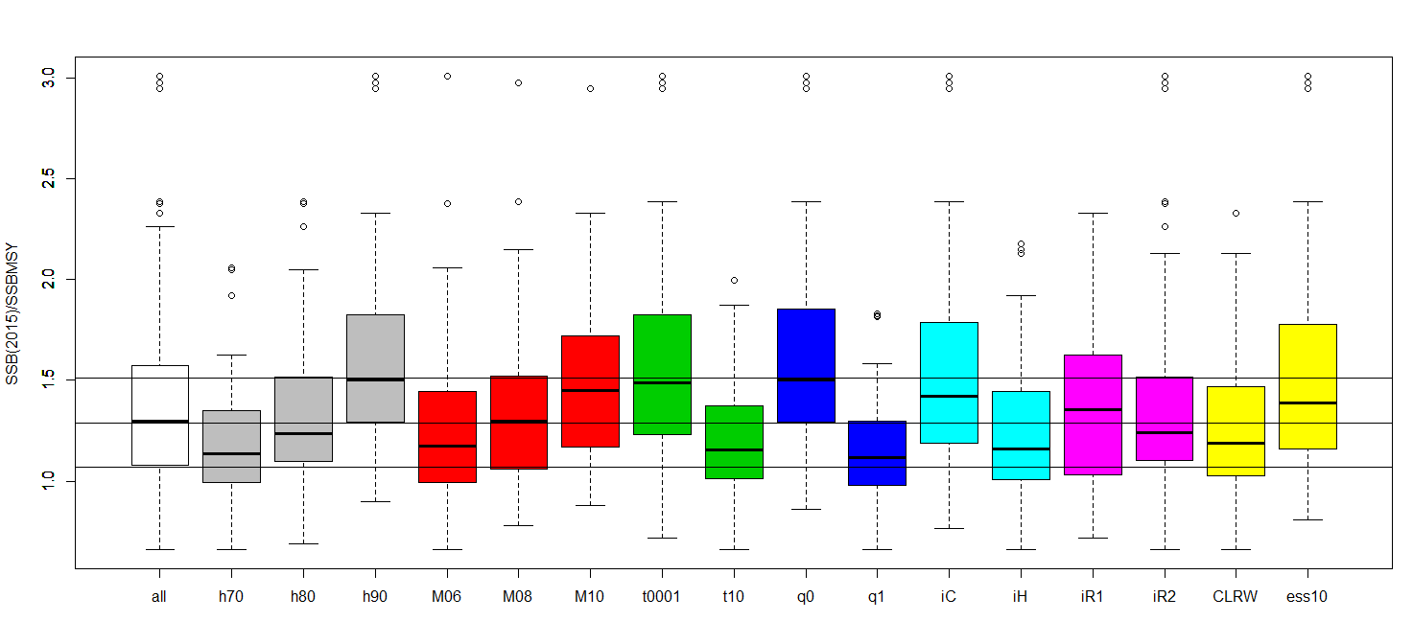
B19.2 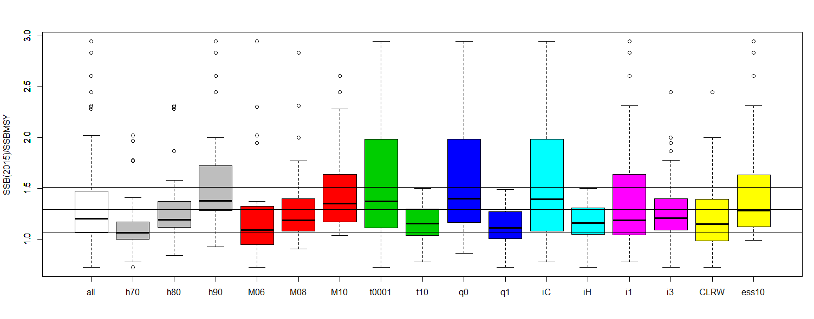
B19.3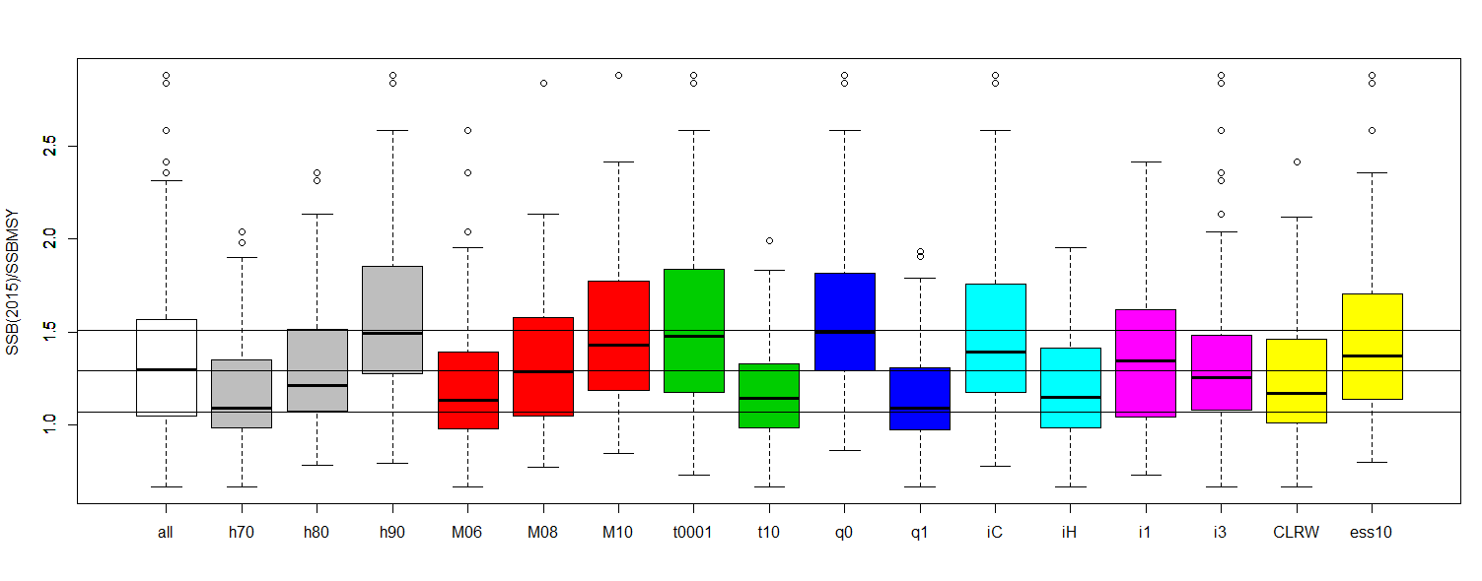
B19.4 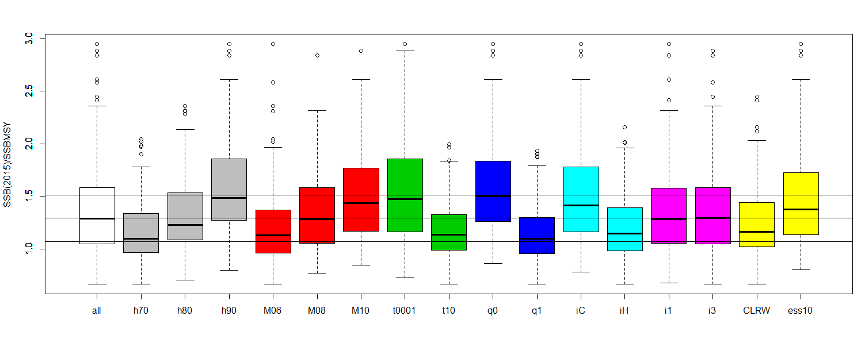

Figure 19. Comparison of estimated current depletion among BET OM ensembles.

B19.0 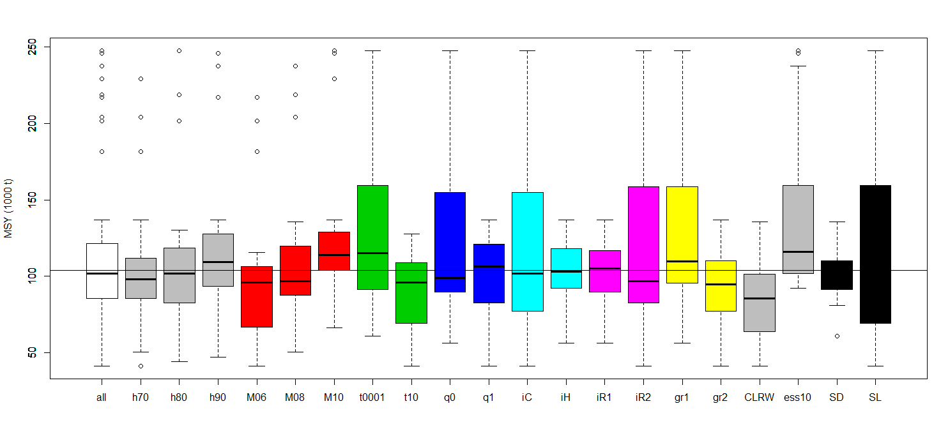
B19.5 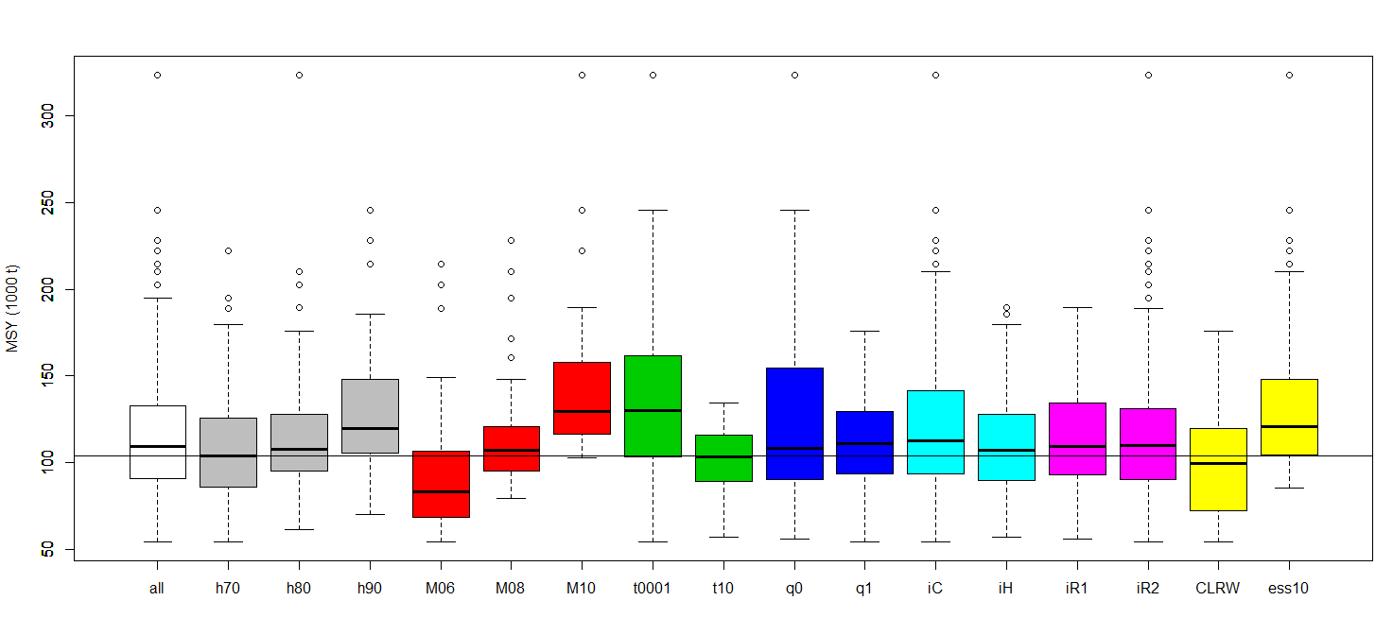
B19.2 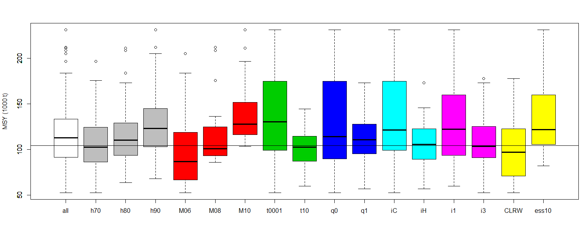
B19.3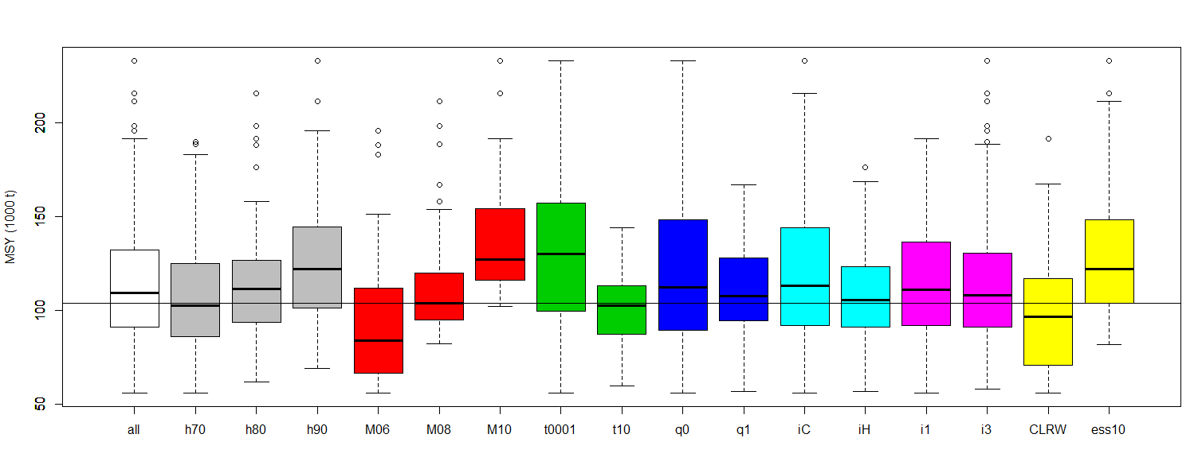
B19.4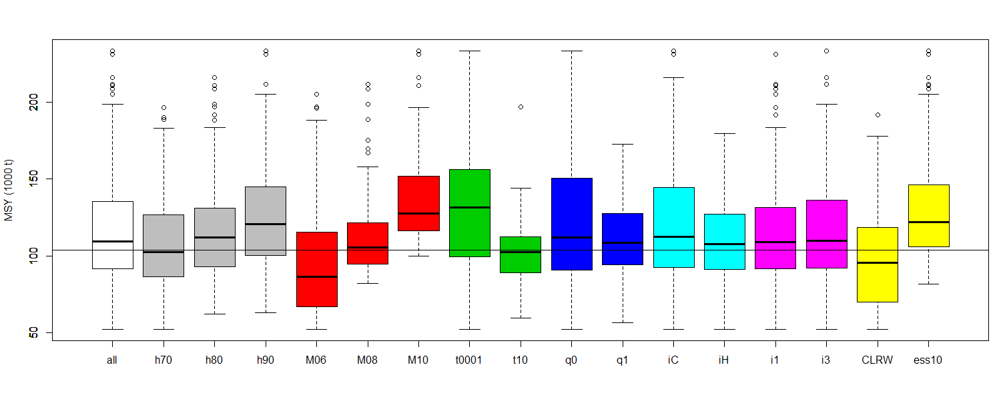

Figure 20. Comparison of estimated MSY among BET OM ensembles.

B19.0 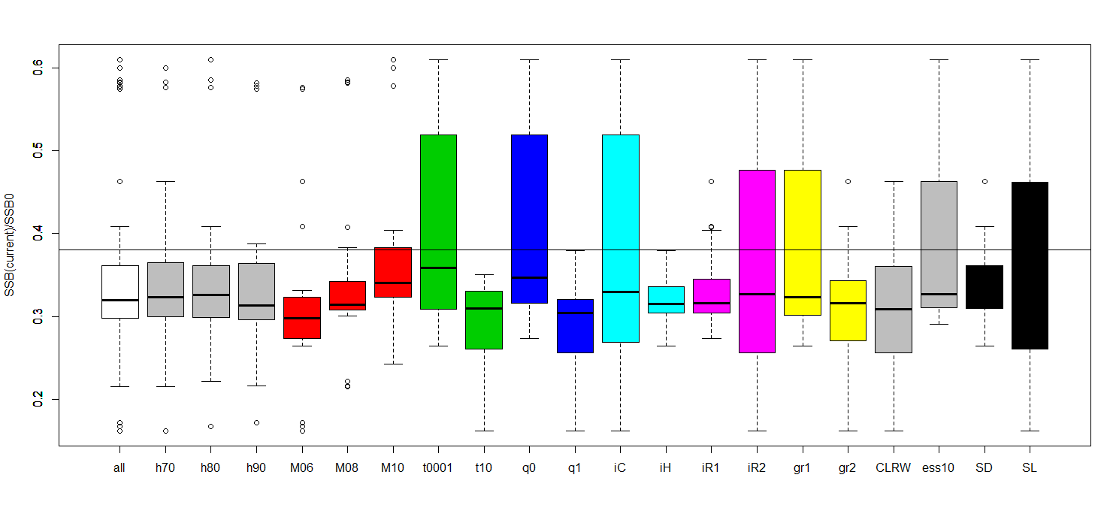
B19.5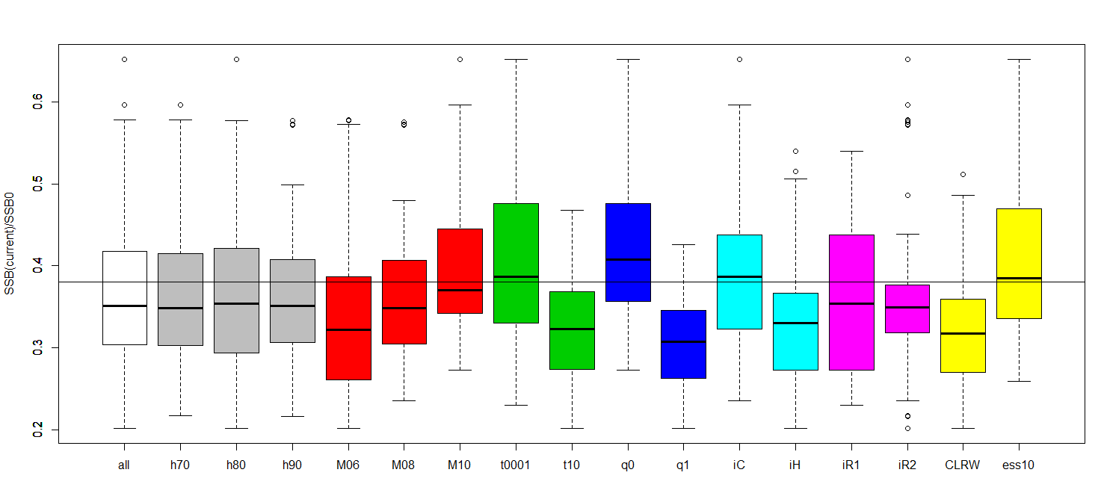

Figure 21. Distribution of depletion estimates for OMgridB19.0 and OMgridB19.5

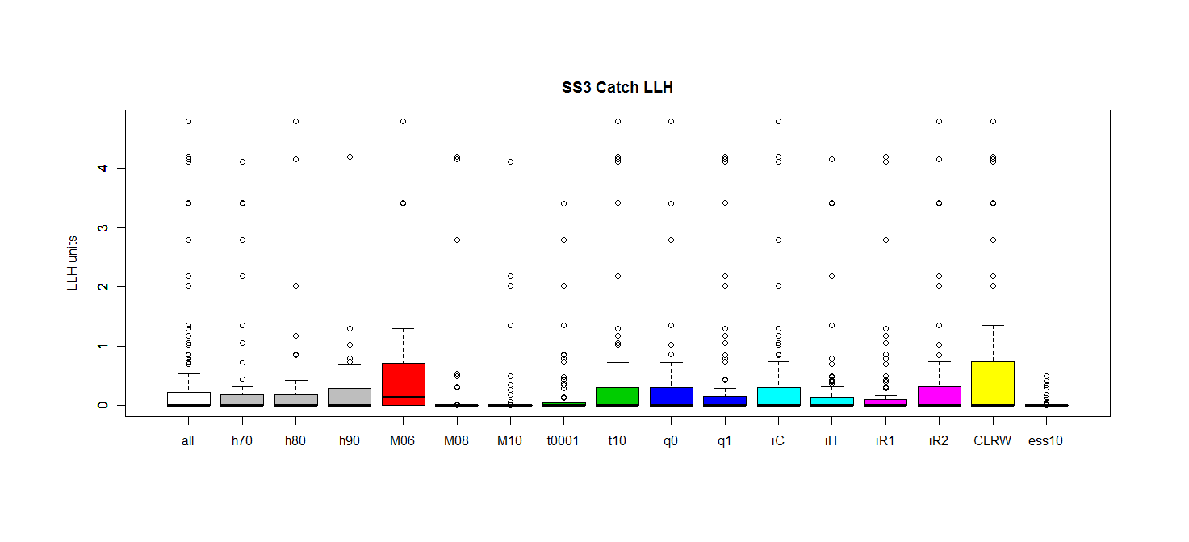
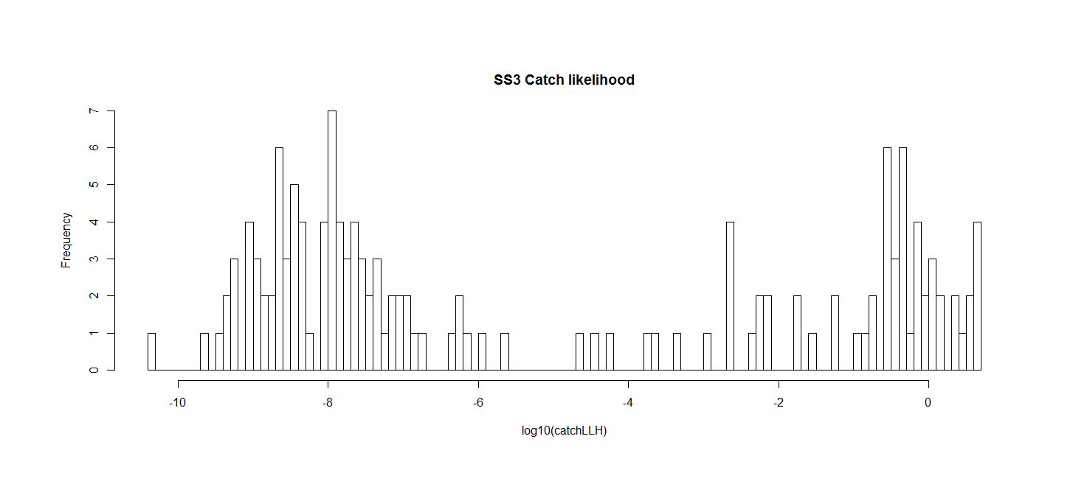

Figure 22. Distribution of catch likelihood terms for OMgridB19.5.

Bigeye MP evaluation results

Figure 23. Big Eye reference case (B19.5). Mean SSB / SSBMSY estimates, partitioned by assumptions (all models are encompassed within an individual colour set).
Figure 24. Big Eye reference case (B19.5). Mean Catch estimates, partitioned by assumptions (all models are encompassed within an individual colour set).
Figure 25. Big Eye reference case (B19.54). Mean Catch/MSY estimates, partitioned by assumptions (all models are encompassed within an individual colour set).
Figure 26. Big Eye reference case (B19.5). C(t)/C(t-1) estimates, partitioned by assumptions (all models are encompassed within an individual colour set).
Figure 27. Big Eye reference case (B19.5). Catch Variability estimates, partitioned by assumptions (all models are encompassed within an individual colour set).
Figure 28. Big Eye reference case (B19.5). F/FMSY estimates, partitioned by assumptions (all models are encompassed within an individual colour set).
Figure 29. Big Eye reference case (B19.5). Probability Catch < 0.1MSY estimates, partitioned by assumptions (all models are encompassed within an individual colour set).
Figure 30. Big Eye reference case (B19.5). Probability SB > SBlim estimates, partitioned by assumptions (all models are encompassed within an individual colour set).
Figure 31. Big Eye reference case (B19.5). Probability in Green Kobe estimates, partitioned by assumptions (all models are encompassed within an individual colour set).
Figure 32. Big Eye reference case (B19.5). Probability in Red Kobe estimates, partitioned by assumptions (all models are encompassed within an individual colour set).
Figure 33. Big Eye reference case (B19.5). Probability SSB > 0.2 SSB0 estimates, partitioned by assumptions (all models are encompassed within an individual colour set).
Figure 34. Big Eye reference case (B19.5). Boxplots comparing candidate MPs with respect to key performance measures averaged over the period 2019 - 2038. Horizontal line is the median, boxes represent 25th - 75th percentiles, thin lines represent 10th - 90th percentiles. Red and green horizontal lines represent the interim limit and target reference points for the mean SB/SBMSY performance measure. The horizontal dashed black line is 2016 catch.
Figure 35. Big Eye reference case (B19.5). Trade-off plots comparing candidate MPs with respect to catch on the X-axis, and 4 other key performance measures on the Y-axis, each averaged over the period 2019 - 2038. Circle is the median, lines represent 10th-90th percentiles. Red and green horizontal lines represent the interim limit and target reference points for the mean SB/SBMSY performance measure. The dashed vertical black line is 2016 catch.
Figure 36. Big Eye reference case (B19.5). Kobe plot comparing candidate MPs on the basis of the expected 20 year average (2019-2038) performance. Circle is the median, lines represent 10th-90th percentiles.
Figure 37. Big Eye reference case (B19.5). Proportion of simulations in each of the Kobe quadrants over time for each of the candidate MPs. Historical estimates are included in the top panel. The lower panels are projections, with the first MP application indicated by the broken vertical line (2019).
Figure 38. Big Eye reference case (B19.5). Time series of spawning stock size for the candidate MPs. The top panel represents the historical estimates from the reference case operating model, and lower plots represent the projection period. The solid vertical line represents the last year used in the historical conditioning. The broken vertical line represents the first year that the MP is applied. The median is represented by the bold black line, the dark shaded ribbon represents the 25th-75th percentiles, the light shaded ribbon represents the 10th-90th percentiles. Thick broken lines represent the interim target (green) and limit (red) reference points. The 3 thin coloured lines represent examples of individual realizations (the same OM scenarios across MPs and performance measures), to illustrate that individual variability greatly exceeds the median.
Figure 39. Big Eye reference case (B19.5). Time series of fishing intensity (Upper bound truncated at F = 3) for the candidate MPs. The top panel represents the historical estimates from the reference case operating model, and lower plots represent the projection period. The solid vertical line represents the last year used in the historical conditioning. The broken vertical line represents the first year that the MP is applied. The median is represented by the bold black line, the dark shaded ribbon represents the 25th-75th percentiles, the light shaded ribbon represents the 10th-90th percentiles. Thick broken lines represent the interim target (green) and limit (red) reference points. The 3 thin coloured lines represent examples of individual realizations (the same OM scenarios across MPs and performance measures), to illustrate that individual variability greatly exceeds the median.
Figure 40. Big Eye reference case (B19.5). Time series of catch for the candidate MPs. The top panel represents the historical estimates from the reference case operating model, and lower plots represent the projection period. The solid vertical line represents the last year used in the historical conditioning. The broken vertical line represents the first year that the MP is applied. The median is represented by the bold black line, the dark shaded ribbon represents the 25th-75th percentiles, the light shaded ribbon represents the 10th-90th percentiles. The broken black horizontal line represents recent (2016) catch. The 3 thin coloured lines represent examples of individual realizations (the same OM scenarios across MPs and performance measures), to illustrate that individual variability greatly exceeds the median.

Table 3. Big Eye Reference case (B19.5). Performance of candidate MPs with respect to key performance measures (averaged over the period 2019-2038) for grid B19.0. Shading indicates the relative performance (darker = better).
 | Performance Measure
Management Procedure | SB/SB_{MSY} | Prob(Green) | Prob(SB>limit) | Mean Catch | Catch Variability
PT41.t15.Gk.mean-0.5 | 1.23 (0.89-1.64) | 0.57 | 0.85 | 107.9 (74.3-134.6) | 4.72
PT41.t15.Gk.mean-0.6 | 1.31 (0.99-1.69) | 0.64 | 0.89 | 104.8 (73.4-129.0) | 4.39
PT41.t15.Gk.mean-0.7 | 1.37 (1.07-1.75) | 0.71 | 0.90 | 100.7 (71.9-123.7) | 3.94
IT5.t15.Gk.mean-0.5 | 1.21 (0.84-1.60) | 0.56 | 0.82 | 108.7 (80.0-136.8) | 4.74
IT5.t15.Gk.mean-0.6 | 1.27 (0.95-1.69) | 0.62 | 0.86 | 104.0 (73.3-131.8) | 4.52
IT5.t15.Gk.mean-0.7 | 1.39 (1.08-1.79) | 0.70 | 0.89 | 95.6 (67.0-123.3) | 4.50

Table 4. Big Eye reference case (B19.5). Candidate MP performance for standard IOTC performance measures for the 20 year period 2019-2038
Status : maximise stock status |  | 20 year average
 |  | PT41.t15.Gk.mean-0.5 | PT41.t15.Gk.mean-0.6 | PT41.t15.Gk.mean-0.7 | IT5.t15.Gk.mean-0.5 | IT5.t15.Gk.mean-0.6 | IT5.t15.Gk.mean-0.7
Mean spawner biomass relative to pristine | SB/SB₀ | 0.34 | 0.36 | 0.38 | 0.33 | 0.35 | 0.39
Minimum spawner biomass relative to pristine | SB/SB₀ | 0.21 | 0.25 | 0.27 | 0.16 | 0.20 | 0.26
Mean spawner biomass relative to SBMSY | SB/SB_{MSY} | 1.23 | 1.31 | 1.37 | 1.21 | 1.27 | 1.39
Mean fishing mortality relative to FMSY | F/F_{tar} | 0.89 | 0.80 | 0.74 | 1.00 | 0.87 | 0.73
Mean fishing mortality relative to target | F/F_{MSY} | 0.89 | 0.80 | 0.74 | 1.00 | 0.87 | 0.73
Probability of being in Kobe green quadrant | SB,F | 0.57 | 0.64 | 0.71 | 0.56 | 0.62 | 0.70
Probability of being in Kobe red quadrant | SB,F | 0.32 | 0.26 | 0.21 | 0.35 | 0.29 | 0.22
Safety : maximise the probability of remaining above low stock status (i.e. minimise risk)
Probability of spawner biomass being above 20% of SB0 | SB | 0.77 | 0.82 | 0.85 | 0.74 | 0.79 | 0.83
Probability of spawner biomass being above BLim | SB | 0.85 | 0.89 | 0.90 | 0.82 | 0.86 | 0.89
Yield : maximise catches across regions and gears
Mean catch (1000 t) | C | 107.93 | 104.75 | 100.69 | 108.70 | 103.97 | 95.63
Mean relative CPUE (aggregate) | C | 0.93 | 0.90 | 0.86 | 0.94 | 0.88 | 0.80
Mean catch relative to MSY | C/MSY | 0.80 | 0.84 | 0.89 | 0.77 | 0.83 | 0.90
Stability: maximise stability in catches to reduce commercial uncertainty
Mean absolute proportional change in catch | C | 4.72 | 4.39 | 3.94 | 4.74 | 4.52 | 4.50
% Catch coefficient of variation | C | 0.18 | 0.16 | 0.15 | 0.19 | 0.17 | 0.16
Probability of shutdown | C | 0.05 | 0.04 | 0.04 | 0.04 | 0.04 | 0.04

-show OMgridB19.0 MP results partitioned by factor - note effect of CPUE CV, regional scaling and growth curve
-show key results from OMgridB19.4 - confirm that there appears to be no need to introduce any additional tuning level (?).

Projection Robustness tests

a)
b)
c)
d)
Figure 41. Big Eye bobustness cases (B19.5) : a) annual aggregate CPUE CV=0.3 and auto-correlation=0.5; b) 10% reported over-catch; c) 10% unreported over-catch; d) 3% p.a. longline catchability trend. Mean SSB / SSBMSY estimates, partitioned by assumptions (all models are encompassed within an individual colour set).

a)
b)
c)
d)
Figure 42. Big Eye bobustness cases (B19.5) : a) annual aggregate CPUE CV=0.3 and auto-correlation=0.5; b) 10% reported over-catch; c) 10% unreported over-catch; d) 3% p.a. longline catchability trend. Mean Catch estimates, partitioned by assumptions (all models are encompassed within an individual colour set).

a)
b)
c)
d)
Figure 43. Big Eye bobustness cases (B19.5) : a) annual aggregate CPUE CV=0.3 and auto-correlation=0.5; b) 10% reported over-catch; c) 10% unreported over-catch; d) 3% p.a. longline catchability trend. Mean Catch/MSY estimates, partitioned by assumptions (all models are encompassed within an individual colour set).

a)
b)
c)
d)
Figure 44. Big Eye bobustness cases (B19.5) : a) annual aggregate CPUE CV=0.3 and auto-correlation=0.5; b) 10% reported over-catch; c) 10% unreported over-catch; d) 3% p.a. longline catchability trend. C(t)/C(t-1) estimates, partitioned by assumptions (all models are encompassed within an individual colour set).

a)
b)
c)
d)
Figure 45. Big Eye bobustness cases (B19.5) : a) annual aggregate CPUE CV=0.3 and auto-correlation=0.5; b) 10% reported over-catch; c) 10% unreported over-catch; d) 3% p.a. longline catchability trend. Catch Variability estimates, partitioned by assumptions (all models are encompassed within an individual colour set).

a)
b)
c)
d)
Figure 46. Big Eye bobustness cases (B19.5) : a) annual aggregate CPUE CV=0.3 and auto-correlation=0.5; b) 10% reported over-catch; c) 10% unreported over-catch; d) 3% p.a. longline catchability trend. F/FMSY estimates, partitioned by assumptions (all models are encompassed within an individual colour set).

a)
b)
c)
d)
Figure 47. Big Eye bobustness cases (B19.5) : a) annual aggregate CPUE CV=0.3 and auto-correlation=0.5; b) 10% reported over-catch; c) 10% unreported over-catch; d) 3% p.a. longline catchability trend. Probability Catch < 0.1MSY estimates, partitioned by assumptions (all models are encompassed within an individual colour set).

a)
b)
c)
d)
Figure 48. Big Eye bobustness cases (B19.5) : a) annual aggregate CPUE CV=0.3 and auto-correlation=0.5; b) 10% reported over-catch; c) 10% unreported over-catch; d) 3% p.a. longline catchability trend. Probability SB > SBlim estimates, partitioned by assumptions (all models are encompassed within an individual colour set).

a)
b)
c)
d)
Figure 49. Big Eye bobustness cases (B19.5) : a) annual aggregate CPUE CV=0.3 and auto-correlation=0.5; b) 10% reported over-catch; c) 10% unreported over-catch; d) 3% p.a. longline catchability trend. Probability in Green Kobe estimates, partitioned by assumptions (all models are encompassed within an individual colour set).

a)
b)
c)
d)
Figure 50. Big Eye bobustness cases (B19.5) : a) annual aggregate CPUE CV=0.3 and auto-correlation=0.5; b) 10% reported over-catch; c) 10% unreported over-catch; d) 3% p.a. longline catchability trend. Probability in Red Kobe estimates, partitioned by assumptions (all models are encompassed within an individual colour set).

a)
b)
c)
d)
Figure 51. Big Eye bobustness cases (B19.5) : a) annual aggregate CPUE CV=0.3 and auto-correlation=0.5; b) 10% reported over-catch; c) 10% unreported over-catch; d) 3% p.a. longline catchability trend. Probability SSB > 0.2 SSB0 estimates, partitioned by assumptions (all models are encompassed within an individual colour set).

a)
b)
Figure 52. Big Eye bobustness cases (B19.5) : a) annual aggregate CPUE CV=0.3 and auto-correlation=0.5; b) 10% reported over-catch. Boxplots comparing candidate MPs with respect to key performance measures averaged over the period 2019 - 2038. Horizontal line is the median, boxes represent 25th - 75th percentiles, thin lines represent 10th - 90th percentiles. Red and green horizontal lines represent the interim limit and target reference points for the mean SB/SBMSY performance measure. The horizontal dashed black line is 2016 catch.

c)
d)
Figure 52. Big Eye bobustness cases (B19.5) : c) 10% unreported over-catch; d) 3% p.a. longline catchability trend. Boxplots comparing candidate MPs with respect to key performance measures averaged over the period 2019 - 2038. Horizontal line is the median, boxes represent 25th - 75th percentiles, thin lines represent 10th - 90th percentiles. Red and green horizontal lines represent the interim limit and target reference points for the mean SB/SBMSY performance measure. The horizontal dashed black line is 2016 catch.

a)
b)
Figure 52. Big Eye bobustness cases (B19.5) : a) annual aggregate CPUE CV=0.3 and auto-correlation=0.5; b) 10% reported over-catch. Trade-off plots comparing candidate MPs with respect to catch on the X-axis, and 4 other key performance measures on the Y-axis, each averaged over the period 2019 - 2038. Circle is the median, lines represent 10th-90th percentiles. Red and green horizontal lines represent the interim limit and target reference points for the mean SB/SBMSY performance measure. The dashed vertical black line is 2016 catch.

c)
d)
Figure 52. Big Eye bobustness cases (B19.5) : c) 10% unreported over-catch; d) 3% p.a. longline catchability trend. Trade-off plots comparing candidate MPs with respect to catch on the X-axis, and 4 other key performance measures on the Y-axis, each averaged over the period 2019 - 2038. Circle is the median, lines represent 10th-90th percentiles. Red and green horizontal lines represent the interim limit and target reference points for the mean SB/SBMSY performance measure. The dashed vertical black line is 2016 catch.

a)
b)
Figure 52. Big Eye bobustness cases (B19.5) : a) annual aggregate CPUE CV=0.3 and auto-correlation=0.5; b) 10% reported over-catch. Kobe plot comparing candidate MPs on the basis of the expected 20 year average (2019-2038) performance. Circle is the median, lines represent 10th-90th percentiles.

c)
d)
Figure 52. Big Eye bobustness cases (B19.5) : c) 10% unreported over-catch; d) 3% p.a. longline catchability trend. Kobe plot comparing candidate MPs on the basis of the expected 20 year average (2019-2038) performance. Circle is the median, lines represent 10th-90th percentiles.

Figure 52. Big Eye bobustness cases (B19.5) a) annual aggregate CPUE CV=0.3 and auto-correlation=0.5. Proportion of simulations in each of the Kobe quadrants over time for each of the candidate MPs. Historical estimates are included in the top panel. The lower panels are projections, with the first MP application indicated by the broken vertical line (2019).

Figure 52. Big Eye bobustness cases (B19.5) b) 10% reported over-catch. Proportion of simulations in each of the Kobe quadrants over time for each of the candidate MPs. Historical estimates are included in the top panel. The lower panels are projections, with the first MP application indicated by the broken vertical line (2019).

Figure 52. Big Eye bobustness cases (B19.5) c) 10% unreported over-catch. Proportion of simulations in each of the Kobe quadrants over time for each of the candidate MPs. Historical estimates are included in the top panel. The lower panels are projections, with the first MP application indicated by the broken vertical line (2019).

Figure 52. Big Eye bobustness cases (B19.5) d) 3% p.a. longline catchability trend. Proportion of simulations in each of the Kobe quadrants over time for each of the candidate MPs. Historical estimates are included in the top panel. The lower panels are projections, with the first MP application indicated by the broken vertical line (2019).

Figure 52. Big Eye bobustness cases (B19.5) a) annual aggregate CPUE CV=0.3 and auto-correlation=0.5. Time series of spawning stock size for the candidate MPs. The top panel represents the historical estimates from the reference case operating model, and lower plots represent the projection period. The solid vertical line represents the last year used in the historical conditioning. The broken vertical line represents the first year that the MP is applied. The median is represented by the bold black line, the dark shaded ribbon represents the 25th-75th percentiles, the light shaded ribbon represents the 10th-90th percentiles. Thick broken lines represent the interim target (green) and limit (red) reference points. The 3 thin coloured lines represent examples of individual realizations (the same OM scenarios across MPs and performance measures), to illustrate that individual variability greatly exceeds the median.

Figure 52. Big Eye bobustness cases (B19.5) b) 10% reported over-catch. Time series of spawning stock size for the candidate MPs. The top panel represents the historical estimates from the reference case operating model, and lower plots represent the projection period. The solid vertical line represents the last year used in the historical conditioning. The broken vertical line represents the first year that the MP is applied. The median is represented by the bold black line, the dark shaded ribbon represents the 25th-75th percentiles, the light shaded ribbon represents the 10th-90th percentiles. Thick broken lines represent the interim target (green) and limit (red) reference points. The 3 thin coloured lines represent examples of individual realizations (the same OM scenarios across MPs and performance measures), to illustrate that individual variability greatly exceeds the median.

Figure 52. Big Eye bobustness cases (B19.5) c) 10% unreported over-catch. Time series of spawning stock size for the candidate MPs. The top panel represents the historical estimates from the reference case operating model, and lower plots represent the projection period. The solid vertical line represents the last year used in the historical conditioning. The broken vertical line represents the first year that the MP is applied. The median is represented by the bold black line, the dark shaded ribbon represents the 25th-75th percentiles, the light shaded ribbon represents the 10th-90th percentiles. Thick broken lines represent the interim target (green) and limit (red) reference points. The 3 thin coloured lines represent examples of individual realizations (the same OM scenarios across MPs and performance measures), to illustrate that individual variability greatly exceeds the median.

Figure 52. Big Eye bobustness cases (B19.5) d) 3% p.a. longline catchability trend. Time series of spawning stock size for the candidate MPs. The top panel represents the historical estimates from the reference case operating model, and lower plots represent the projection period. The solid vertical line represents the last year used in the historical conditioning. The broken vertical line represents the first year that the MP is applied. The median is represented by the bold black line, the dark shaded ribbon represents the 25th-75th percentiles, the light shaded ribbon represents the 10th-90th percentiles. Thick broken lines represent the interim target (green) and limit (red) reference points. The 3 thin coloured lines represent examples of individual realizations (the same OM scenarios across MPs and performance measures), to illustrate that individual variability greatly exceeds the median.

Figure 52. Big Eye bobustness cases (B19.5) a) annual aggregate CPUE CV=0.3 and auto-correlation=0.5. Time series of fishing intensity (Upper bound truncated at F = 3) for the candidate MPs. The top panel represents the historical estimates from the reference case operating model, and lower plots represent the projection period. The solid vertical line represents the last year used in the historical conditioning. The broken vertical line represents the first year that the MP is applied. The median is represented by the bold black line, the dark shaded ribbon represents the 25th-75th percentiles, the light shaded ribbon represents the 10th-90th percentiles. Thick broken lines represent the interim target (green) and limit (red) reference points. The 3 thin coloured lines represent examples of individual realizations (the same OM scenarios across MPs and performance measures), to illustrate that individual variability greatly exceeds the median.

Figure 52. Big Eye bobustness cases (B19.5) b) 10% reported over-catch. Time series of fishing intensity (Upper bound truncated at F = 3) for the candidate MPs. The top panel represents the historical estimates from the reference case operating model, and lower plots represent the projection period. The solid vertical line represents the last year used in the historical conditioning. The broken vertical line represents the first year that the MP is applied. The median is represented by the bold black line, the dark shaded ribbon represents the 25th-75th percentiles, the light shaded ribbon represents the 10th-90th percentiles. Thick broken lines represent the interim target (green) and limit (red) reference points. The 3 thin coloured lines represent examples of individual realizations (the same OM scenarios across MPs and performance measures), to illustrate that individual variability greatly exceeds the median.

Figure 52. Big Eye bobustness cases (B19.5) c) 10% unreported over-catch. Time series of fishing intensity (Upper bound truncated at F = 3) for the candidate MPs. The top panel represents the historical estimates from the reference case operating model, and lower plots represent the projection period. The solid vertical line represents the last year used in the historical conditioning. The broken vertical line represents the first year that the MP is applied. The median is represented by the bold black line, the dark shaded ribbon represents the 25th-75th percentiles, the light shaded ribbon represents the 10th-90th percentiles. Thick broken lines represent the interim target (green) and limit (red) reference points. The 3 thin coloured lines represent examples of individual realizations (the same OM scenarios across MPs and performance measures), to illustrate that individual variability greatly exceeds the median.

Figure 52. Big Eye bobustness cases (B19.5) d) 3% p.a. longline catchability trend. Time series of fishing intensity (Upper bound truncated at F = 3) for the candidate MPs. The top panel represents the historical estimates from the reference case operating model, and lower plots represent the projection period. The solid vertical line represents the last year used in the historical conditioning. The broken vertical line represents the first year that the MP is applied. The median is represented by the bold black line, the dark shaded ribbon represents the 25th-75th percentiles, the light shaded ribbon represents the 10th-90th percentiles. Thick broken lines represent the interim target (green) and limit (red) reference points. The 3 thin coloured lines represent examples of individual realizations (the same OM scenarios across MPs and performance measures), to illustrate that individual variability greatly exceeds the median.

Figure 52. Big Eye bobustness cases (B19.5) a) annual aggregate CPUE CV=0.3 and auto-correlation=0.5. Time series of catch for the candidate MPs. The top panel represents the historical estimates from the reference case operating model, and lower plots represent the projection period. The solid vertical line represents the last year used in the historical conditioning. The broken vertical line represents the first year that the MP is applied. The median is represented by the bold black line, the dark shaded ribbon represents the 25th-75th percentiles, the light shaded ribbon represents the 10th-90th percentiles. The broken black horizontal line represents recent (2016) catch. The 3 thin coloured lines represent examples of individual realizations (the same OM scenarios across MPs and performance measures), to illustrate that individual variability greatly exceeds the median.

Figure 52. Big Eye bobustness cases (B19.5) b) 10% reported over-catch. Time series of catch for the candidate MPs. The top panel represents the historical estimates from the reference case operating model, and lower plots represent the projection period. The solid vertical line represents the last year used in the historical conditioning. The broken vertical line represents the first year that the MP is applied. The median is represented by the bold black line, the dark shaded ribbon represents the 25th-75th percentiles, the light shaded ribbon represents the 10th-90th percentiles. The broken black horizontal line represents recent (2016) catch. The 3 thin coloured lines represent examples of individual realizations (the same OM scenarios across MPs and performance measures), to illustrate that individual variability greatly exceeds the median.

Figure 52. Big Eye bobustness cases (B19.5) c) 10% unreported over-catch. Time series of catch for the candidate MPs. The top panel represents the historical estimates from the reference case operating model, and lower plots represent the projection period. The solid vertical line represents the last year used in the historical conditioning. The broken vertical line represents the first year that the MP is applied. The median is represented by the bold black line, the dark shaded ribbon represents the 25th-75th percentiles, the light shaded ribbon represents the 10th-90th percentiles. The broken black horizontal line represents recent (2016) catch. The 3 thin coloured lines represent examples of individual realizations (the same OM scenarios across MPs and performance measures), to illustrate that individual variability greatly exceeds the median.

Figure 52. Big Eye bobustness cases (B19.5) d) 3% p.a. longline catchability trend. Time series of catch for the candidate MPs. The top panel represents the historical estimates from the reference case operating model, and lower plots represent the projection period. The solid vertical line represents the last year used in the historical conditioning. The broken vertical line represents the first year that the MP is applied. The median is represented by the bold black line, the dark shaded ribbon represents the 25th-75th percentiles, the light shaded ribbon represents the 10th-90th percentiles. The broken black horizontal line represents recent (2016) catch. The 3 thin coloured lines represent examples of individual realizations (the same OM scenarios across MPs and performance measures), to illustrate that individual variability greatly exceeds the median.

Aside from the new uncertainty dimensions discussed above, seven additional robustness scenarios were proposed in the WPTT/WPM 2018. The first four were addressed by changing the OM projection assumptions (key result figs (using B19.4 + central tuning to reference case)). The last three were not addressed for reasons discussed below.
- Annual aggregated CPUE CV = 0.3 (auto-correlation = 0.5)
- 10% reported over-catch (projections only; reference case conditioning)
- 10% unreported over-catch (projections only; reference case conditioning)
- 3% LL catchability trend (projections only; reference case conditioning)
- Spatial Structure- possibly additional area around eastern INDONESIA, another in the Bay of Bengal Region and the area around Oman (other area stratification as is).
  - This is a major restructuring of model assumptions that would require considerable data processing. The request would require a more explicit definition, and an explanation of the rationale seems warranted. Given that the assessment already appears to be over-parameterized, with unstable parameter estimation, adding more complexity with areas that probably cannot be reliably linked with tags or longline CPUE series does not seem like a fruitful avenue for exploration.
- Non stationary M, linf and K in the projections.
  - While untested to date, the OM includes the functionality to add some or all of these features. However, before venturing down this route, we would like the proponents to provide specific requests (e.g. magnitude of change, time series structure) ideally with some empirical justification.
- Stock Structure (based on ongoing IO stock structure project).
  - While untested to date, the OM was originally designed to include this functionality. However, this adds considerable complexity in terms of conditioning assumptions and the provision of summary statistics etc. This was deferred as a longer term goal, ideally informed by the ongoing Indian Ocean stock structure project.

Discussion Points for the IOTC MSE Task Force:

Based on these results, we recommend that the reference case BET OM for the 2019 TCMP should consist of the following grid options and levels:
h70, h80, h90
M10, M08, M06
t0001, t10
q0, q1
iH, iC
ess10, CLRW
i3 only (LL CPUE CV = 0.3)
gr1 (original growth curve only)
ir1

- We recommend dropping the alterative growth curve at this time, because it is an ad hoc hybrid that is not statistically defensible. It can lead to implausible stock dynamics estimates. If it was retained, the uniform plausibility weighting assumption would need to be revisited for some factor interactions. But growth is probably worth revisiting at a future date, in relation to inter-lab ageing method comparisons that are currently underway. It may also require non-trivial restructuring of the assessment and OM to represent spatial/temporal variability in growth.

- We recommend reducing the input CPUE CV conditioning option levels to 0.3 only, since it did not appear to have a material effect on results.

- We recommend retaining the single preferred option area-weighting scheme for longline CPUE indices because the stock status results were not very sensitive to the other plausible alternatives.

- We recommend using a fractional factorial design that results in a manageable number of conditioned models in the ensemble of around 50 - 150, includes all interactions between the 3 level assumptions h and M, allows all main effects of all 2 level options to be estimable, and includes all 2-way interactions if the number of models can be kept below ~150.

- We recommend retaining the repeated convergence procedure to minimize the probability of accepting outlier models due to extreme numerical convergence problems.

- We recommend retaining a hard bound on the fishing intensity at the initial equilibrium level.

- As with previous iterations, we do not have any argument for deviating from the uniform weighting scheme within the OM ensemble.

- We consider that this analysis has addressed the requested conditioning robustness scenarios for xxx and xxx. The other robustness scenarios that are based on projection assumptions will be addressed and quantified for the 2019 WPTT and WPM. However, as in previous iterations, robustness tests will not be presented to the 2019 TCMP. Other robustness scenarios, including alternative spatial structure,

Appendix 1. Extracts from the 2018 Methods and Tropical Tuna Working Party reports relevant to bigeye and yellowfin MSE

Methods Working Group (2018) draft report
- Bigeye tuna and yellowfin tuna MSE: update

Review of Operating Models based on WPM and SC feedback, including possible robustness tests
- The WPM NOTED that two presentations were made in this section, summarizing three related working papers, IOTC–2018–WPM09–09 (BET OM definition), IOTC–2018–WPM09–10 (YFT OM definition) and IOTC–2018–WPM09–11 (BET and YFT MP Evaluations).
- The WP NOTED that the MSE for both species is being pursued in the strict sense of MP in which the MP consists of simulation-tested combination of data collection, analysis methods and HCR (which makes this work different to the SKJ assessment, when no specification on data and analyses methods was made)
- The WPM NOTED paper IOTC–2018–WPM09–09 which provided an update on the IOTC Bigeye Tuna MSE Operating Model Development. The following abstract was provided by the authors:
“This paper summarizes progress on the development of Operating Models (OMs) for IOTC bigeye (BET) tuna. Additional background detail on recent software developments is provided in the yellowfin (YFT) companion paper (Kolody and Jumppanen 2018f). MP evaluation updates for BET and YFT are described in Kolody and Jumppanen (2018a). This paper builds on the work presented and reviewed at the IOTC informal MSE Working Group in March 2018 (Kolody and Jumppanen 2018d,e), and represents the first time that the formal IOTC WPTT and WPM have the opportunity to review the substantial BET OM developments since the phase 1 work was completed in 2016. (See paper for full abstract):
- The WPM SUGGESTED the following changes to the reference case OM grid:
  - CPUE variability set to a level that would result in an annual CV of 0.2 (retaining auto-correlation of 0.5)
  - Extend bridging catches, with first TAC in 2021
  - Additional uncertainty dimensions:
    - alternative growth function (noting the large effect on the recent WCPFC bigeye assessment). WPTT asked to review and specify the most appropriate alternative. This could be a robustness scenario.
    - alternative regional CPUE scaling factors
    - alternative historical catch series. Proposals were discussed, but the options were thought to either not represent a large change from the preferred series, or were difficult to justify as plausible.
- The WPM RECOMMENDED exploring partially-confounded experimental design as a computationally tractable method for expanding the number of uncertainty dimensions and the main interactions (at the expense of losing higher order interactions). It should be adopted if if it is not found to have a significant reduction in full grid uncertainty.
- The WPM SUGGESTED the following priorities for robustness scenarios:
  - Annual aggregated CPUE CV = 0.3 (auto-correlation = 0.5)
  - 10% reported over-catch (projections only; reference case conditioning)
  - 10% unreported over-catch (projections only; reference case conditioning)
  - 3% LL catchability trend (projections only; reference case conditioning)
  - Spatial Structure- possibly additional area around eastern INDONESIA, another in the Bay of Bengal Region and the area around Oman (other area stratification as is).
  - Non stationary M, linf and K in the projections.
  - Stock Structure (based on ongoing IO stock structure project).
- The WPM NOTED that some of these robustness tests should be considered long-term ambitions, which would require more specific definitions and input from the secretariat and external parties, and would likely delay the current development timeline.
- The WPM NOTED that some of the effects tested separately in the Robustness scenarios could eventually happen simultaneously and at least some scenarios should consider these effects in combination (e.g. catch misreporting and recruitment failure in the same simulation). However, it was further noted that an MP cannot be expected to handle every adverse situation and "exceptional circumstances" procedures are applicable in the worst cases
- The WPM NOTED paper IOTC–2018–WPM09–10 which provided an update on the IOTC Yellowfin Tuna Operating Model Development. The following abstract was provided by the authors:
“This paper summarizes progress on the development of Operating Models (OMs) for IOTC yellowfin (YFT) tuna. MP evaluation updates for yellowfin and bigeye tunas are described in Kolody and Jumppanen (2018a). This paper builds on the work presented and reviewed at the IOTC informal MSE Working Group in March 2018 (Kolody and Jumppanen 2018d,e).
The latest version of the MSE software is publicly available from github, with a recently updated technical description and user manual (https://github.com/pjumppanen/niMSE-IO-BET-YFT/).The BET and YFT MSE projection software has undergone several changes in the past year, with a substantial rewrite to improve memory usage and parallel processing, which greatly improves MP evaluation speed. Most of these changes to the computational engine are not visible to the end user. (See paper for full abstract):”
- The WPM NOTED the high uncertainty and large number of implausible models in the uniformly weighted grid of the YFT Reference set OMs. It was recognised that the proposed approach of sampling the uniform grid with respect to the central tendency of the assessment was not ideal, but represented a pragmatic path forward.
- The WPM DISCUSSED the alternative option of filtering plausible models in relation to habitat constraints as was used for albacore, and noted the following disadvantages in this case:
  - It is not obvious that a meta-analysis of the productivity of 3 or 4 other YFT populations would provide more valuable insight about productivity than the arguments employed within the IOTC assessment process.
  - The YFT MSY distribution forms a long-tailed continuum, unlike the disjointed polymodal distribution for ALB
  - Unlike ALB, the YFT distribution also had many models that were implausibly unproductive (not only over-productive)
- The WPM SUGGESTED the following changes to the YFT reference set OM grid, and expected that the WPTT would refine these recommendations, particularly with respect to insights from the new YFT assessment:
  - CPUE variability set to a level that would result in an annual CV of 0.2 (retaining auto-correlation of 0.5)
  - Extend bridging catches, with first TAC in 2021
  - Additional uncertainty dimensions:
    - alternative growth function (noting the large effect on the recent WCPFC bigeye assessment). WPTT will be asked to review and specify the most appropriate alternative. This could be a robustness scenario.
    - alternative regional CPUE scaling factors
    - alternative historical catch series. Proposals were discussed, but the options were thought to either not represent a large change from the preferred series, or were difficult to justify as plausible.
    - It was noted that a new YFT catch data series will be discussed for the assessment at the WPTT, which is probably appropriate for the OM as well

  - Sample the OM grid using the bi-variate sampling approach (sampling with respect to the central tendency of MSE and SB(current)/SB(MSY), but with variance assumptions that are compatible with the distributional characteristics of the BET grid (for consistency)
- The WPM RECOMMENDED exploring partially-confounded experimental design as a computationally tractable method for expanding the number of uncertainty dimensions and the main interactions (at the expense of losing higher order interactions). It should be adopted if if it is not found to have a significant reduction in full grid uncertainty.
- The WP SUGGESTED the following priorities for robustness scenarios:
  - Annual aggregated CPUE CV = 0.3 (auto-correlation = 0.5)
  - 10% reported over-catch (projections only; reference case conditioning)
  - 10% unreported over-catch (projections only; reference case conditioning)
  - 3% LL catchability trend (projections only; reference case conditioning)
  - dome-shaped longline selectivity (noting potential for interaction with M and growth)
- The WPM NOTED that some of these robustness tests should be considered long-term ambitions, which would require more specific definitions and input from the secretariat and external parties, and would likely delay the current development timeline.
- The WPM NOTED that some of the effects tested separately in the Robustness scenarios could eventually happen simultaneously and at least some scenarios should consider these effects in combination (e.g. catch misreporting and recruitment failure in the same simulation). However, it was further noted that an MP cannot be expected to handle every adverse situation and "exceptional circumstances" procedures are applicable in the worst cases
- The WPM NOTED that alternative MP tuning levels should be adopted to add contrast to the results for the TCMP02.

Working Party on Tropical Tuna (2018) draft report

Bigeye
- The WPTT NOTED paper IOTC–2018–WPM09–09 which provided an update on IOTC bigeye tuna operating model development, October 2018, including the following summary provided by the authors:
“This paper summarizes progress on the development of Operating Models (OMs) for IOTC bigeye (BET) tuna. Additional background detail on recent software developments is provided in the yellowfin (YFT) companion paper (Kolody and Jumppanen 2018f). MP evaluation updates for BET and YFT are described in Kolody and Jumppanen (2018a). This paper builds on the work presented and reviewed at the IOTC informal MSE Working Group in March 2018 (Kolody and Jumppanen 2018d,e), and represents the first time that the formal IOTC WPTT and WPM have the opportunity to review the substantial BET OM developments since the phase 1 work was completed in 2016.”
- The WPTT reviewed and ENDORSED the progress to date on MSE for bigeye tuna while recognizing the discussions held at TCMP and the advice of WPM, but INDICATED the need to consider some additional uncertainty dimensions in the bigeye tuna MSE workplan agreed by WPM.
- In particular, WPTT ENCOURAGED that the MSE work consider the importance of an alternative growth curve for bigeye tuna. The WPTT SUGGESTED the growth curve estimated by Farley et. al. (2016) is based on a broader size range (up to 160cm+) and may have a more plausible Linf value (~178 cm) than the Eveson (2015) model currently used in the OM. Furthermore, the Farley et. al. (2016) growth curve is derived from samples from the eastern Indian Ocean so may provide additional information on growth from a different region. However, the WPTT acknowledged that the Farley et. al. (2016) growth function may not describe well the length-at-age for fish smaller than 70cm LJFL which is the size range of most of the tagged fish for which the model estimates age.
- Therefore, the WPTT SUGGESTED either anchoring the growth curve to a plausible age at zero length, or preferably combining the data from the Farley et al. (2006) growth curve with the Eveson (2015) and fitting both Von-Bertalanffy Growth Function (VBGF) and multi-stanza growth models to determine the best model fit.
- The WPTT expressed some concern in combining size at age data from different time periods to estimate a single growth curve due to the potential for temporal shifts in growth, but also NOTED that the inclusion of an additional growth curve was to capture a plausible range of uncertainty in growth.
- The WPTT NOTED that there may be a need to revise the number of age classes used in the models when using a different growth curve due to shift in the distribution of size at age

Yellowfin
  - Update on Management Strategy Evaluation Progress
- The WPTT NOTED paper IOTC–2018–WPM09–10, which provided an update on the development of the operating model for IOTC yellowfin tuna (October 2018).
- The WPTT NOTED paper IOTC–2018–WPM09–11, which provided an update on IOTC bigeye and yellowfin management procedure evaluation progress (October 2018), including the following abstract provided by the authors:
“ This document presents MP evaluation results for bigeye and yellowfin tunas, using the new operating models (OMs) proposed in Kolody and Jumppanen (2018a, b) and the new tuning levels requested by TCMP (2018). The results of various robustness scenarios are included, at this point largely to help facilitate the discussion of their role in the MP development and selection process and how they should be presented to the TCMP.”
- The WPTT reviewed and ENDORSED the progress to date on MSE for yellowfin tuna while recognizing the discussions held at TCMP and the advice of WPM, but INDICATED the need to alter some of the assumptions used in the operating model grid and consider some additional uncertainty dimensions in the yellowfin tuna MSE workplan agreed by WPM.
- The WPTT NOTED the need to modify the assumed time required to achieve mixing of tagged YFT with the untagged population to 4 quarters (from 3 quarters) based on decisions taken for the 2018 YFT stock assessment. Further, the WPTT ENCOURAGED that the MSE work consider the importance of also assuming the time needed for mixing of the tagged and untagged populations of 8 quarters for use in examining robustness of MPs to this assumption.
- The WPTT ENCOURAGED that the MSE work consider the importance of alternative growth for yellowfin tuna based on the growth model estimated by Dortel (2014) for use in examining robustness of yellowfin MPs to alternative growth models.
- The WPTT further ENCOURAGED that the MSE work also consider the importance of adding the Purse Seine Free School CPUE as documented in IOTC–2018–WPTT20–36_Rev1, assuming a 1% per year cumulative increase in catchability (q) for the time period, for use in examining robustness of yellowfin MPs.
- The WPTT also NOTED that the decisions taken for the 2018 YFT assessment regarding short-term and chronic tag loss differed from the YFT Operating Model grid and RECOMMENDED that the 2018 YFT assessment assumptions be mimicked in the Operating Model grid.
- The WPTT NOTED that the proposed new uncertainty dimensions would be evaluated with respect to plausibility and impact before deciding whether to assign them to the OM reference set or robustness trials. The informal MSE working group will review these decisions in March 2019.

